**The Mechanisms of a Successful Web Business**

By Jamie Millman

Student number: 12814408

Digital Media Development

University of Brighton

Table of Contents

Website references 3

1. Introduction 4

2. Background Research 5

2.1 The Brighton Fuse 5

2.2 Brighton Fuse 2: Freelancer Report 6

2.3 The Lean Startup 7

3. Research 8

3.1 Competitors Tools 8

3.2 Framework and Toolkit Analysis 10

3.3 Social Media Presence 17

3.4 Operation Procedures 20

3.5 Registering my Business 23

3.6 Joining an Association 24

3.7 Insurance Policies 24

3.8 Owning Intellectual Property 25

3.9 Site Accessibility 26

3.9.1 Perceivable information and user experience 26

3.9.2 Operable user interface from a keyboard 27

3.9.3 Understandable information and user interface 27

3.9.4 Robust content and reliable interpretation 28

4. Business Plan 29

5. My company 39

5.1 Company name 39

5.2 Company logos 40

5.2.2 Crank Design & Development 40

5.2.3 Crank Creations 41

5.3 Company colour scheme 41

5.4 Company Layout Ideas 42

5.5 Company Assets 42

5.5.1 Icons 42

5.5.2 Illustrations 44

5.6 Company Business Cards 46

5.7 Company fonts 46

6. Evaluation 48

6.1 Analysis of the Research 48

6.2 Analysis of the Products 49

6.3 Analysis of the Marketing 51

6.4 Conclusion 52

7. Bibliography 53

Appendix 1 – Design stage 58

Appendix 1.1 – Logo designs 58

1.1.1 Majime 58

1.1.2 Crank design & development 59

1.1.3 Crank Creations 61

Appendix 1.2 – Layout designs 62

1.2.1 Global Sections Navigation 62

1.2.2 Homepage Full page 63

1.2.3 Work page Full page 65

1.2.5 About page Full page 68

Appendix 1.3 – Illustration designs 71

Appendix 2 – Usability test 74

Appendix 3 – Terms & Conditions 82

# Website references

**Company website**

<http://www.crankcreations.com/>

**Client websites**

<http://www.jem-in-the-rough.com/>

<http://speakthespeech.co.uk/demo_website_2/>

**Research blogging website**

<https://finalprojectlogblog.wordpress.com/>

# 1. Introduction

In this report I will analyse all of the imperative stages needed to create a successful web business. In order to understand what makes a web business successful, I have done extensive research within the industry and analysed the positive and negative aspects of various web companies. I did this to highlight the essential features that encapsulated a successful web business.

I compiled background research on the current digital market and analysed how my company would be situated within it. I reflected on the research I had done on the toolkits used within other web companies. This helped me gain a better understanding of why certain tools are more commonly used, to help choose the appropriate toolkit for my company.

During my research I analysed social media platforms and selected the correct ones to market my business on. I then researched the accessibility of websites and how to cater them towards those with disabilities. Researching the inner workings of a business is very important. I was able to select the correct legal status of my business, choose the right insurance policies, ensure I owned my intellectual property and correctly create an array of operational procedures (invoices, project proposals, payment packages and terms & conditions).

I regularly attended meetings, events and lectures relating to my final project. This was to gain knowledge and experience to implement into my business. I created a blog to help document the positive and negative aspects from each one. *(See the URL link on page 3 to access my research blog)*

After I completed the research stages for my business, I created my business plan. The business plan helped me understand my company’s aims and goals and how to achieve them.

I designed my company’s brand from the research previously gathered. This included: layouts, colour scheme, logo, assets, fonts and the company name. After the design process was completed I began the development of my company website. I orchestrated a user test to help analyse the functionality and design of the website. With the information gained I was able to correct errors and add new features.

Once all of the design and development had been completed I marketed my company using SEO (search engine optimisation), and through social media platforms. I searched for clients to create websites for, utilising all of the information I learnt from this project.

Finally I evaluated the products I created: my business website, the client websites and my business cards. I explained how the research I gained from competitor companies and the user tests, were key to the success of my business website. I evaluated the entire project to see if the aims and objectives had been met. Following this I highlighted the improvements that still needed to be made.

# 2. Background Research

This section covers the background research I sourced from websites and literature. This information helped me gain a better understanding of the local digital sector and the business world in general.

## 2.1 The Brighton Fuse

I began researching about the current state of the digital market in Brighton & Hove. I discovered a project called The Brighton Fuse.[1] This is a project run by Wired Sussex[2], the University of Brighton[3], the University of Sussex[4] and the Council of Industry & Higher Education.[5] It is a research and development project that lasted two years. During these two years they analysed the growth of Brighton’s successful, creative, digital and information technology (CDIT) cluster. The Brighton Fuse discovered a new business approach that when bringing together creativity and technology, can improve the success of a business. These businesses are called ‘super fused’. The Brighton Fuse has empirical evidence to show that combining the arts, humanities and design; with creative, digital and IT skills, enhances business creativity, innovation and growth.[6]

The Brighton Fuse talked about the qualities that make a super fused individual in the Brighton CDIT cluster. These include networking very frequently and placing great emphasis on creativity & business innovation. 65% of these super fused individuals combine creative design and technology with new business processes.[7]

From researching about The Brighton Fuse I can clearly see how combining creativity and technology would greatly improve the success of a business. I will be constantly exercising the traits that make up a super fused individual, and implementing creativity to every aspect of my business. By doing this I believe it will increase the chance of having a successful business.

## 2.2 Brighton Fuse 2: Freelancer Report

After I finished researching The Brighton Fuse, I noticed they recently released a second report. This report focused primarily on freelancers and how in creative, digital and IT sectors they fuel prosperity, success and growth. This report mentioned that freelancers enjoy good incomes, and are satisfied with their employment status.

The Brighton Fuse 2 report asks the question, “To what extent does your work combine ideas from creative design and technology?” If you were to say “a lot” then you would be classed as super fused, “to some extent” you would be fused and “hardly at all” you would be un-fused. Statistics show that 46.7% of freelancers are super fused, compared to 34.7% in firms. One of the most interesting results of the Fuse project is that “the creative and digital firms in the cluster are strongly supported by a local community of freelancers. The average firm in the sample worked with 7 freelancers in the period 2011-2012, with 79% of firms working with at least one freelancer during the period”.[8]

This evidence shows that firms in the Brighton CDIT cluster are working with super fused freelancers to help developing new innovative ideas. As a result generating more work for freelancers across Brighton & Hove.[9]

After researching about The Brighton Fuse 2 project, it gave me confidence in creating a new business. Before reading this report I was unsure about the current market and what was needed to create a successful business. Since reading the Brighton Fuse reports I believe it has equipped me with the right theoretical tools to create a successful business.

## 2.3 The Lean Startup

The Lean Startup looks at a new approach coined by Eric Ries. It states that it will build companies and launch products faster. These products will be more in line with customer needs, reduce long development times and the amount of funding needed to launch a company. This is achieved by companies building a minimum viable product, a version of the product with the bare minimum features. The product is tested on users at an early stage for feedback. It eradicates the long hours creating a product without knowing the customer’s wants or needs. When a product is ready to test, the customers might not want certain features or even the whole product. After they have shown the customers the MVP (minimum viable product), they hear their feedback. Then it is decided whether to: continue to build the product, tweak the existing product or pivot. Pivot is commonly used during the start-up of a business. A pivot is a “change in direction to test hypothesis about product, strategy or engine of growth”.[10] This is used when your product/business is not achieving what it was initially thought to. However these test results show certain features have the potential to be successful. So you change direction but stay grounded in what you have learnt.[11]

The new approach used in The Lean Startup was informative, therefore I decided to adopt and incorporate it into my business. This approach does not entirely relate to a website design and development business. However it made me grasp the idea of the MVP, helping me to realise my ideas will not always be what a client wants. When creating the first draft of a clients website, I will monitor the time spent working on that draft. This will allow me to consciously reduce my time spent on it, to get earlier feedback and find out what they would like changed. Harnessing this approach will save me a lot of time and in result money, as I will be optimising my time efficiently and not having to backtrack to make alterations at a later stage.

# 3. Research

This section covers the research I compiled from competitor companies, meetings, events and online. I kept a blog to report all of the information gained from the meetings and events, throughout the duration of my project. (See page 3 for the URL to my research blog). This research was used to improve the overall success, professionalism and efficiency of a web business.

# **3.1 Competitors Tools**

To gain more information about the tools I will use in my toolkit, I contacted successful web design companies to find out what tools they use regularly and how they were beneficial.

#### Built by Buffalo

I spoke to Dan Griffiths at Built by Buffalo.[12] I asked him what tools his company used and anything he could recommend to me for my new business. He mentioned that I should research Foundation version 6.[13] Foundation is a large front-end framework that helps with development. However this version has condensed the amount of unnecessary code used to make it more lightweight, and overall better to use. I have used foundation before, but did not want to use a framework for my company. This is to allow more freedom when developing websites. Built by Buffalo use: Sass, CoffeeScript, Git (with Gitlab used for hosting their repository) and their own customised grid. They also use a library that consists of “a few barebones projects, starter elements and design templates honed over the years.”  
  
This conversation with Dan Griffiths gave me an insight into what tools were used regularly at their company. I have analysed these set of tools later in the report to see if they were the correct ones for my company’s projects.  
  
Clearleft

I spoke to Charlotte Jackson at Clearleft about the tools their company use and what they would recommend for a new business. Clearleft “Work with top industry specialists to uncover fresh opportunities, develop your digital strategy, and bring new products and services to life.”[14] I attended a Clearleft technology development meeting. This helped me gain a better understanding of the tools commonly used in their company. This meeting helped me highlight the tools I should be using, along with the benefits of using a patterns library.

Clearleft focus primarily on HTML, CSS and JavaScript. However they believe it is important to have a basic understanding of most tools. Clearleft are very current and keep up to date with technologies and common web trends. Clearleft use pattern libraries[15] for most clients they work with.

From my time spent at Clearleft I gained a large amount of knowledge about toolsets in the industry, and the ones that would benefit my company most. Although there are tools I will focus on more, I have decided to keep up to date with all technologies (new and old). This is to gain a broader understanding of web technologies and web trends in general.  
  
Ten4

Ten4 are a “Web and app strategy, branding, design and development”[16] company located in London. I contacted them to find out what tools they used, to help me choose my correct toolkit. Andy Green at Ten4 spoke about: the tools they use, their common practises and the reasoning behind their decisions. They use their own framework titled ‘Ten4 Framework’.[17] This is where they store all of their templates and tools to use on each project. Andy mentioned that Ten4 use Craft CMS[18] or Slim[19] to build their projects on. They also use Gulp and a personalised Sass library. The Sass library consists of a personalised grid system and a folder they call ‘add-ons’, to save all useful code they reuse for projects (animated slideshows, Google maps etc.). After researching Craft CMS and Slim I decided not to use these CMS’s. Instead I will focus on using a more accessible CMS, WordPress. Once I have learnt to fully understand WordPress I will continue to learn Craft CMS and Slim in more depth. Ten4 are ‘quite anti-jQuery’ and focus on using JavaScript libraries instead. This is because of ‘performance, educational and to lesser extent compatibility reasons’.

The research gained from Built by Buffalo, Clearleft and Ten4 highlighted the tools my company would benefit from using. I was able to focus my research closer on the relevant tools needed for a web business.

## 3.2 Framework and Toolkit Analysis

#### Creating my own set of tools

I decided against using a framework and instead wanted to create my own set of tools for the development of my project. I initially decided to use the new Bootstrap 4 alpha framework.[20] This allowed the user to completely customise their framework, from a lightweight version to one full of features. This meant it was catered to the developer and allowed fast development with pre-defined elements and layouts. The reason I decided against using Bootstrap was mainly because of this. It would not give me enough freedom during the development and without having to remove the pre-defined styles, the client’s website would hold similar features. To remove all of the pre-defined elements in Bootstrap before each project would be a time consuming task.

I decided to create a library that will hold elements of previously used un-styled code to reuse on future projects. This speeds up the development of each project without the use of a large framework.

Many website design and development companies choose to use their own set of toolkit libraries to have a standard template when creating websites. These toolkits provide valuable assets to speed up and improve the development process. These toolkits include: a grid system, a text editor, various CSS and JavaScript libraries, CSS pre-processers, JavaScript pre-processers and version control systems. I will talk in more depth about these tools below.

Sublime Text[21]

Sublime Text is a one of the most popular text editors used by front-end developers. It is a paid text editor that allows free use with occasional prompts to purchase. A text editor is a computer program that allows users to input their chosen coded language. For front-end development (the development of a website or web application) the user would host these documents on a server, so they can be accessed online. A majority of developers would choose a text editor based on preference. The top text editors (Sublime Text and Brackets[22]) have catered their design and functionality to be, user-friendly for a developer. The aspects a developer would desire in text editors are: good colour coding, efficient window management, great extensibility, valuable implementable plugins, easily accessible user interface and autocomplete for various programming languages. I chose to use Sublime Text because it incorporated most of these points well, and the user experience is intuitive and pleasant to use.

Git[23]

Git is a version control system (VCS) that allows you to remotely save changes made to your work. You can then “push” those changes online. “Pushing” in Git is transferring locally saved files online. Once those changes have been “pushed” they are forever saved as the updated version. GitHub is the online repository used to host my files. It displays both new and old edited code allowing the user to view the project’s journey. This allows you to monitor your work and see when certain changes were made. It is an extremely useful tool that I will use on every development task I undertake.

#### Sass

Sass (Syntactically Awesome Style Sheets) is a scripting language that gets interpreted into CSS once it has been processed. This is called a pre-processor. “Sass is the most mature, stable, and powerful professional grade CSS extension language in the world.”[24] In a 2012 survey studies showed that more people preferred using Less[25] to Sass.[26] However through updates and changes Sass has since become the more popular pre-processor. HTML, CSS and JavaScript frameworks such as Foundation, Skeleton[27] and Bootstrap now all focus more on Sass. Foundation has used Sass from the beginning, Skeleton allows both and Bootstrap (the most popular framework) has recently switched from Less to Sass. This shows Sass is beginning to take over as the leading pre-processor. There is a large aspect of personal preference involved in selecting the right pre-processor. After trying both Less and Sass I decided to use Sass because I found it to be a more sophisticated and manageable pre-processor.

Gulp[28]

Gulp is a build tool (or task runner) that allows you to automate various tasks that would originally be manual. Some of these tasks include: compiling Sass, compressing your images, minifying your CSS, minifying your JavaScript and live reloads of a browser page. You would define these tasks in a gulp.js file and run them through the terminal. The initial learning curve of using the terminal and writing the Gulp tasks proved challenging. These are two aspects I have never used for front-end development. Once I began to understand how to use Gulp it became apparent just how much time and effort I would be saving during the development stages of my project.

Custom Grid

Creating a custom grid gives you complete freedom to organise the layout of your website. The most common platforms to access pre-defined grid systems are through frameworks like: Bootstrap, Foundation and Skeleton. You are also able to download stand-alone grid systems such as: 960 Grid System[29], Fluidable[30] and One % Css Grid.[31] I decided to create my own grid system from scratch. The benefits from creating my own grid were: dramatically reduced file size, complete freedom in responsiveness, simplistic terminology to make it accessible and the potential to improve at any stage.

When creating my grid I used a tutorial by Jan Drewniak[32] to get a basic understanding of how a grid system worked. After implementing this basic grid, I began to adapt and improve it to be more catered towards my development preferences. I will continue to improve the grid system, until it fully satisfies my development needs.

CoffeeScript[33]

CoffeeScript is a pre-processed language that compiles into JavaScript. CoffeeScript, like Sass for CSS, changes the syntax needed to write correct code. This is the main reason I chose not to use CoffeeScript for my final project. I wanted to be able to use JavaScript more fluently before learning a pre-processed version of it. I will learn CoffeeScript in the future once my JavaScript has improved, as studies show it is a beneficial pre-processor to use.[34]

Normalize.css[35]vs. CSS reset**[36]**

Normalize.css and CSS reset are used to reduce the amount of inconsistencies between browsers. These inconsistencies include: line height, margins, font sizes and font weights. CSS reset was created before Normalize.css, however since the release of Normalize.css many frameworks, toolkits and sites use it. These include: Twitter Bootstrap, HTML5 Boilerplate, Gov.uk, CSS Tricks and many more.[37]

CSS reset aims to removeall built in browser stylings. Normalize.css aims to make all built in browser stylings consistent. This allows some useful default browser styles to remain, so you don’t have to re-declare styles for common typography elements with Normalize.css. Other benefits for Normalize.css include: fixing desktop and mobile browser bugs that CSS reset cannot (such as SVG overflow in IE9), being modular to allow easier viewing and editing and improved targeting styles to reduce cluttered debugging tools. Normalize.css also has extensive documentation to help fully understand the code.[38]

I decided to choose Normalize.css as my cross platform consistency style sheet. The large amount of documentation Normalize.css has, allowed me to fully understand what I was implementing. It was more efficient to have the default browser styles made consistent as apposed to removing them, therefore I did not have to re-declare basic styles.  
  
Modernizr.js[39] vs. Feature.js**[40]**

Modernizr.js and Feature.js are browser feature detection libraries that run tests as your web page loads. This is to detect what browser the user is running. It then analyses the browser to see what HTML, CSS and JavaScript features will work inside it. This is done to allow all users to have a similar experience when viewing a website. If a user is running an old browser that does not support some of the content on your website, you can implement these JavaScript libraries into your code. This will allow your website to cater a similar experience towards those users.

There is more documentation for Modernizr.js, and it was easier to find tutorials because it was created first. Feature.js is an extremely lightweight, plain JavaScript version of Modernizr.js with a file size of 1kb. Overall Feature.js focuses on delivering a faster service. For example it automatically initializes itself during page

load and does not run tests without the developer’s permission. This makes the performance very fast.

Although Modernizr.js has more documentation to help understand the script better, Feature.js is a newer, faster and cleaner browser feature detection library. It is simple to understand and has enough documentation on the website to easily make your detections quite advanced. These were the reasons I chose Feature.js.

#### JavaScript vs. jQuery

During the research of my toolkit analysis, I contemplated whether to write in JavaScript or jQuery for the development of my project. I have used both infrequently for two years. In previous projects I used jQuery more than JavaScript. I believed it was easier and more efficient as I could achieve a similar result with less lines of code. I decided to research this further, to find out what other developers thought about JavaScript and jQuery. When researching I found several threads and articles explaining the positives and negatives for using both. Overall I found that developers preferred to use JavaScript to jQuery for larger projects. One of the main reasons for this is due to its better performance. This is because of increased loading speed, reduced file size and better optimised performance. jQuery was not specifically designed with mobile in mind so certain functions (like the click function) cause large delays. One of the main benefits of jQuery is the reduced development time and how it’s friendly towards beginners. The reason for this is because it is harder to make mistakes and the API and numerous plugins are easier to use. jQuery is a JavaScript library that makes the developer write different syntax to JavaScript. Developers that do not understand JavaScript would find it hard to learn how the language worked, if primarily using jQuery. I found this to be very important when selecting between the two. If I used pure JavaScript I would be improving my understanding of the language that would be needed, if I wanted to write more advanced code. By focusing on jQuery I would improve my jQuery skills but not my knowledge of JavaScript, the language jQuery is based on. This would allow me to progress to a certain point before inevitably having to learn more about JavaScript.[41]

I communicated with various web design and development companies, and the majority focused on using JavaScript more than jQuery. This may be due to them working on larger projects. However when speaking to Andy from Ten4 he said the following:

*“From experience teaching placement students here, I've found that blind use of jQuery unsurprisingly gives no real understanding of JavaScript programming as a whole. By 'banning' jQuery, we cultivate better problem-solving developers, who are always surprised how simple and flexible the 'proper' way actually is.”*

This reinforced the conclusion I came to from my research, that I should primarily focus on JavaScript until I have a better understanding of the language. I will consider learning more about jQuery once my JavaScript is at a higher level.

#### Patterns Library

After speaking to the development team at Clearleft, I gained a better understanding of pattern libraries and why they are beneficial for certain projects. A pattern library allows code to be broken up into modules. This allows you to isolate sections of code to make it easier for clients to implement into their existing website. These include: footers, sign-up forms and navigation. This is quite a specific way to show a client the deliverables. It would mainly be used with a client that has a technical team that works on their website. This is due to the fact the client receives the code, and implements it into their own website. I am going to use a pattern library called Pattern Lab.[42] This is a free to use pattern library that Charlotte Jackson from Clearleft recommended me to use. I will use this pattern library to gain a better understanding of how it works. Then I will be able to use it to improve the handover of deliverables once I gain the correct client.

Below is a table I compiled to give a visual representation of the tools previously mentioned.

|  |  |  |  |
| --- | --- | --- | --- |
| List of tools | | | |
|  | **Using at the beginning of my project** | **Using in the future of my business** | **Brief description about the tool** |
|  | | |  |
| Sublime text |  |  | A text editor to write code. |
| Git |  |  | A versions control system |
| Sass |  |  | A CSS pre-processor that compiles into CSS. |
| Gulp |  |  | A task runner that helps automate tasks. |
| Custom grid |  |  | A custom-made grid system to allow maximum freedom when structuring the website. |
| CoffeeScript |  |  | A JavaScript pre-processor that compiles into JavaScript |
| Normalize.css |  |  | Helps browsers to render all elements more consistently. |
| Feature.js |  |  | A lightweight browser feature detection library. |
| JavaScript |  |  | A programming language commonly used for interactivity in browsers. |
| jQuery |  |  | JavaScript library used to simplify client side scripting. |
| Pattern Library |  |  | Separates your code into modules to make it easier to send clients specific sections. |

## 3.3 Social Media Presence

Choosing the correct social media platforms is important to the success of a web business. In 2014 studies show that 74% of all online adults used social media.[43] This demonstrates the potential for success when marketing correctly on social media.

#### Facebook

Facebook is currently the most popular social media website with an estimate of 900 million unique monthly visitors.[44] Although Facebook isn’t primarily used for professional businesses, if the page is done correctly it can generate a lot of views and potentially leads. Nutella is a great example of a successful Facebook page. Nutella regularly post: competitions, fun facts, adverts, fans pictures and recipes. By doing this it keeps users/fans interested in your page whilst also marketing to them. Creating interesting and intuitive posts is very important. If a user considers a post interesting enough to share, that post will be displayed to the user’s entire friends list. In result increasing the marketing reach further on Facebook. Photo competitions are a great way to get users to interact with your page. The user would upload a relevant image and tag the company. This would result in images of your products circulating Facebook, potentially getting new users to view your page and generating relevant conversation about your company.[45]

After creating my Facebook page it was important to regularly update it with: fun facts, tutorials, informative posts and progression of the business. By doing this correctly I had a greater chance of gaining a large following on the most popular social media website.

#### Twitter

Twitter is the second most popular social media website with an estimated 310 million unique monthly visitors.[46] Twitter has a good balance between professional and fun as a social media platform. A very important way to successfully market to a large audience is to regularly post (tweet) informative, humorous or interesting content. This must be easily accessible for the general public to interact with. The more users that interact with a post will result in the same post getting re-posted (re-tweeted), allowing more users to view it.

I came across an article titled “9 Small Business Twitter Marketing Examples to Study”.[47] In this article it listed nine points to focus on when creating a professional business twitter account for a small business. Those points were:

1. Use twitter to stand out.
2. Keep your followers interested.
3. Stick with it.
4. Provide a balance of work and fun.
5. Keep your mobile users in mind.
6. Listen to your customers.
7. Promote hard to find products.
8. Connect with people who need what you have to offer.
9. Use twitter for lead generation.

This list shows what is needed to successfully market your business on twitter. Some of the key points from this list are more important for specific projects. The points I believe to be most important for my project are: use twitter to stand out, keep your followers interested, provide a balance of work and fun and listen to your customers.

Using Twitter to stand out is important due to there being so many companies/users actively online. You must try new things to stand out and get people interested in your company.

Keeping your followers interested relates to the previous point, using Twitter to stand out. You may need to stand out to keep users interested and vice versa. I believe this is the most important point on the list. If users begin to lose interest in a company page, it will ultimately result in losing followers and potential customers.

Providing a balance of work and fun is key to my specific business. This is due to the fact that my target audience is very broad. Video game companies tend to have a narrower, more focused target audience that share common interests. This would

make it easier to market to. By providing a balance of work and fun will allow me to engage with a larger audience.

Listening to customers allows your audience to see you are an active online company that communicates. By showing you have fast and effective customer service will stop users un-following your page. Users may also ask questions about videos, competitions and articles posted. Responding to these questions allows them to see your interactivity, encouraging more users to communicate. In result increasing the overall interactivity between companies and their customers.  
  
LinkedIn

LinkedIn is the third most popular social media website, with an estimated 255 million unique monthly users.[48] LinkedIn is the most popular professional social media platform. On your company page it allows you to display: informative content about your company, your specialised skillset, your chosen sector and more. This allows users to gain quick and easy information about your company. For my company it is primarily used to link with professionals and talk about common trends, new developments and important articles around my sector. This helps gain important contacts for future developments of my business.  
  
YouTube

Creating a YouTube channel increases the number of users reached, by marketing on a video-sharing platform. By uploading relevant web tutorials on: design, development and marketing, will gain an audience through informative content. This will connect my company to the source of knowledge gained by those users. By establishing a video backlink to my company website and other social media platforms, it improves the overall ranking through SEO.

Those are the four social media websites I chose to market on. Facebook, Twitter, LinkedIn and YouTube. By marketing on these four platforms, it covers the most amount of audience reached on social media. In result getting my company acknowledged through multiple types of content.

## 3.4 Operation Procedures

I spoke to Sam Zubaidi at Bee Purple to help gain a better understanding of the inner workings of a company. Bee Purple is the University of Brighton’s entrepreneurship network.[49] From this point on I will refer to my company as Crank Creations. *(How I came to this decision will be further explained in Section 5 – My Company).*Terms & conditions

Each client that considers working with Crank Creations gets sent the company’s terms & conditions, to show the legal basis we are willing to do business with them. Our terms & conditions cover: payment terms, copyright law, licencing, rights of refusal, owning property and more. The terms & conditions usually stay the same, however we would need to adapt them slightly for each client to ensure we are protected. (*See Appendix 3 for our full Terms & Conditions).*

#### Project proposal

Crank Creations project proposal will be sent before the project has started alongside the terms & conditions and invoice. It will allow the client to have a visual representation of the project and tasks to be undertaken before accepting.

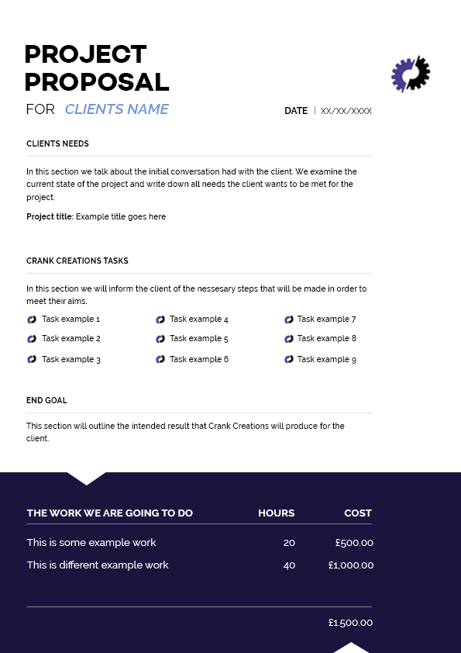

#### Invoice

An invoice is given to the client along with the terms & conditions and project proposal. In the invoice it shows a breakdown of costs and estimated completion time (hours) for the services/product provided. Crank Creations expects fifty per cent of the project fee upfront before production can begin. (*See Appendix 3 for the payment terms in our Terms & Conditions).*

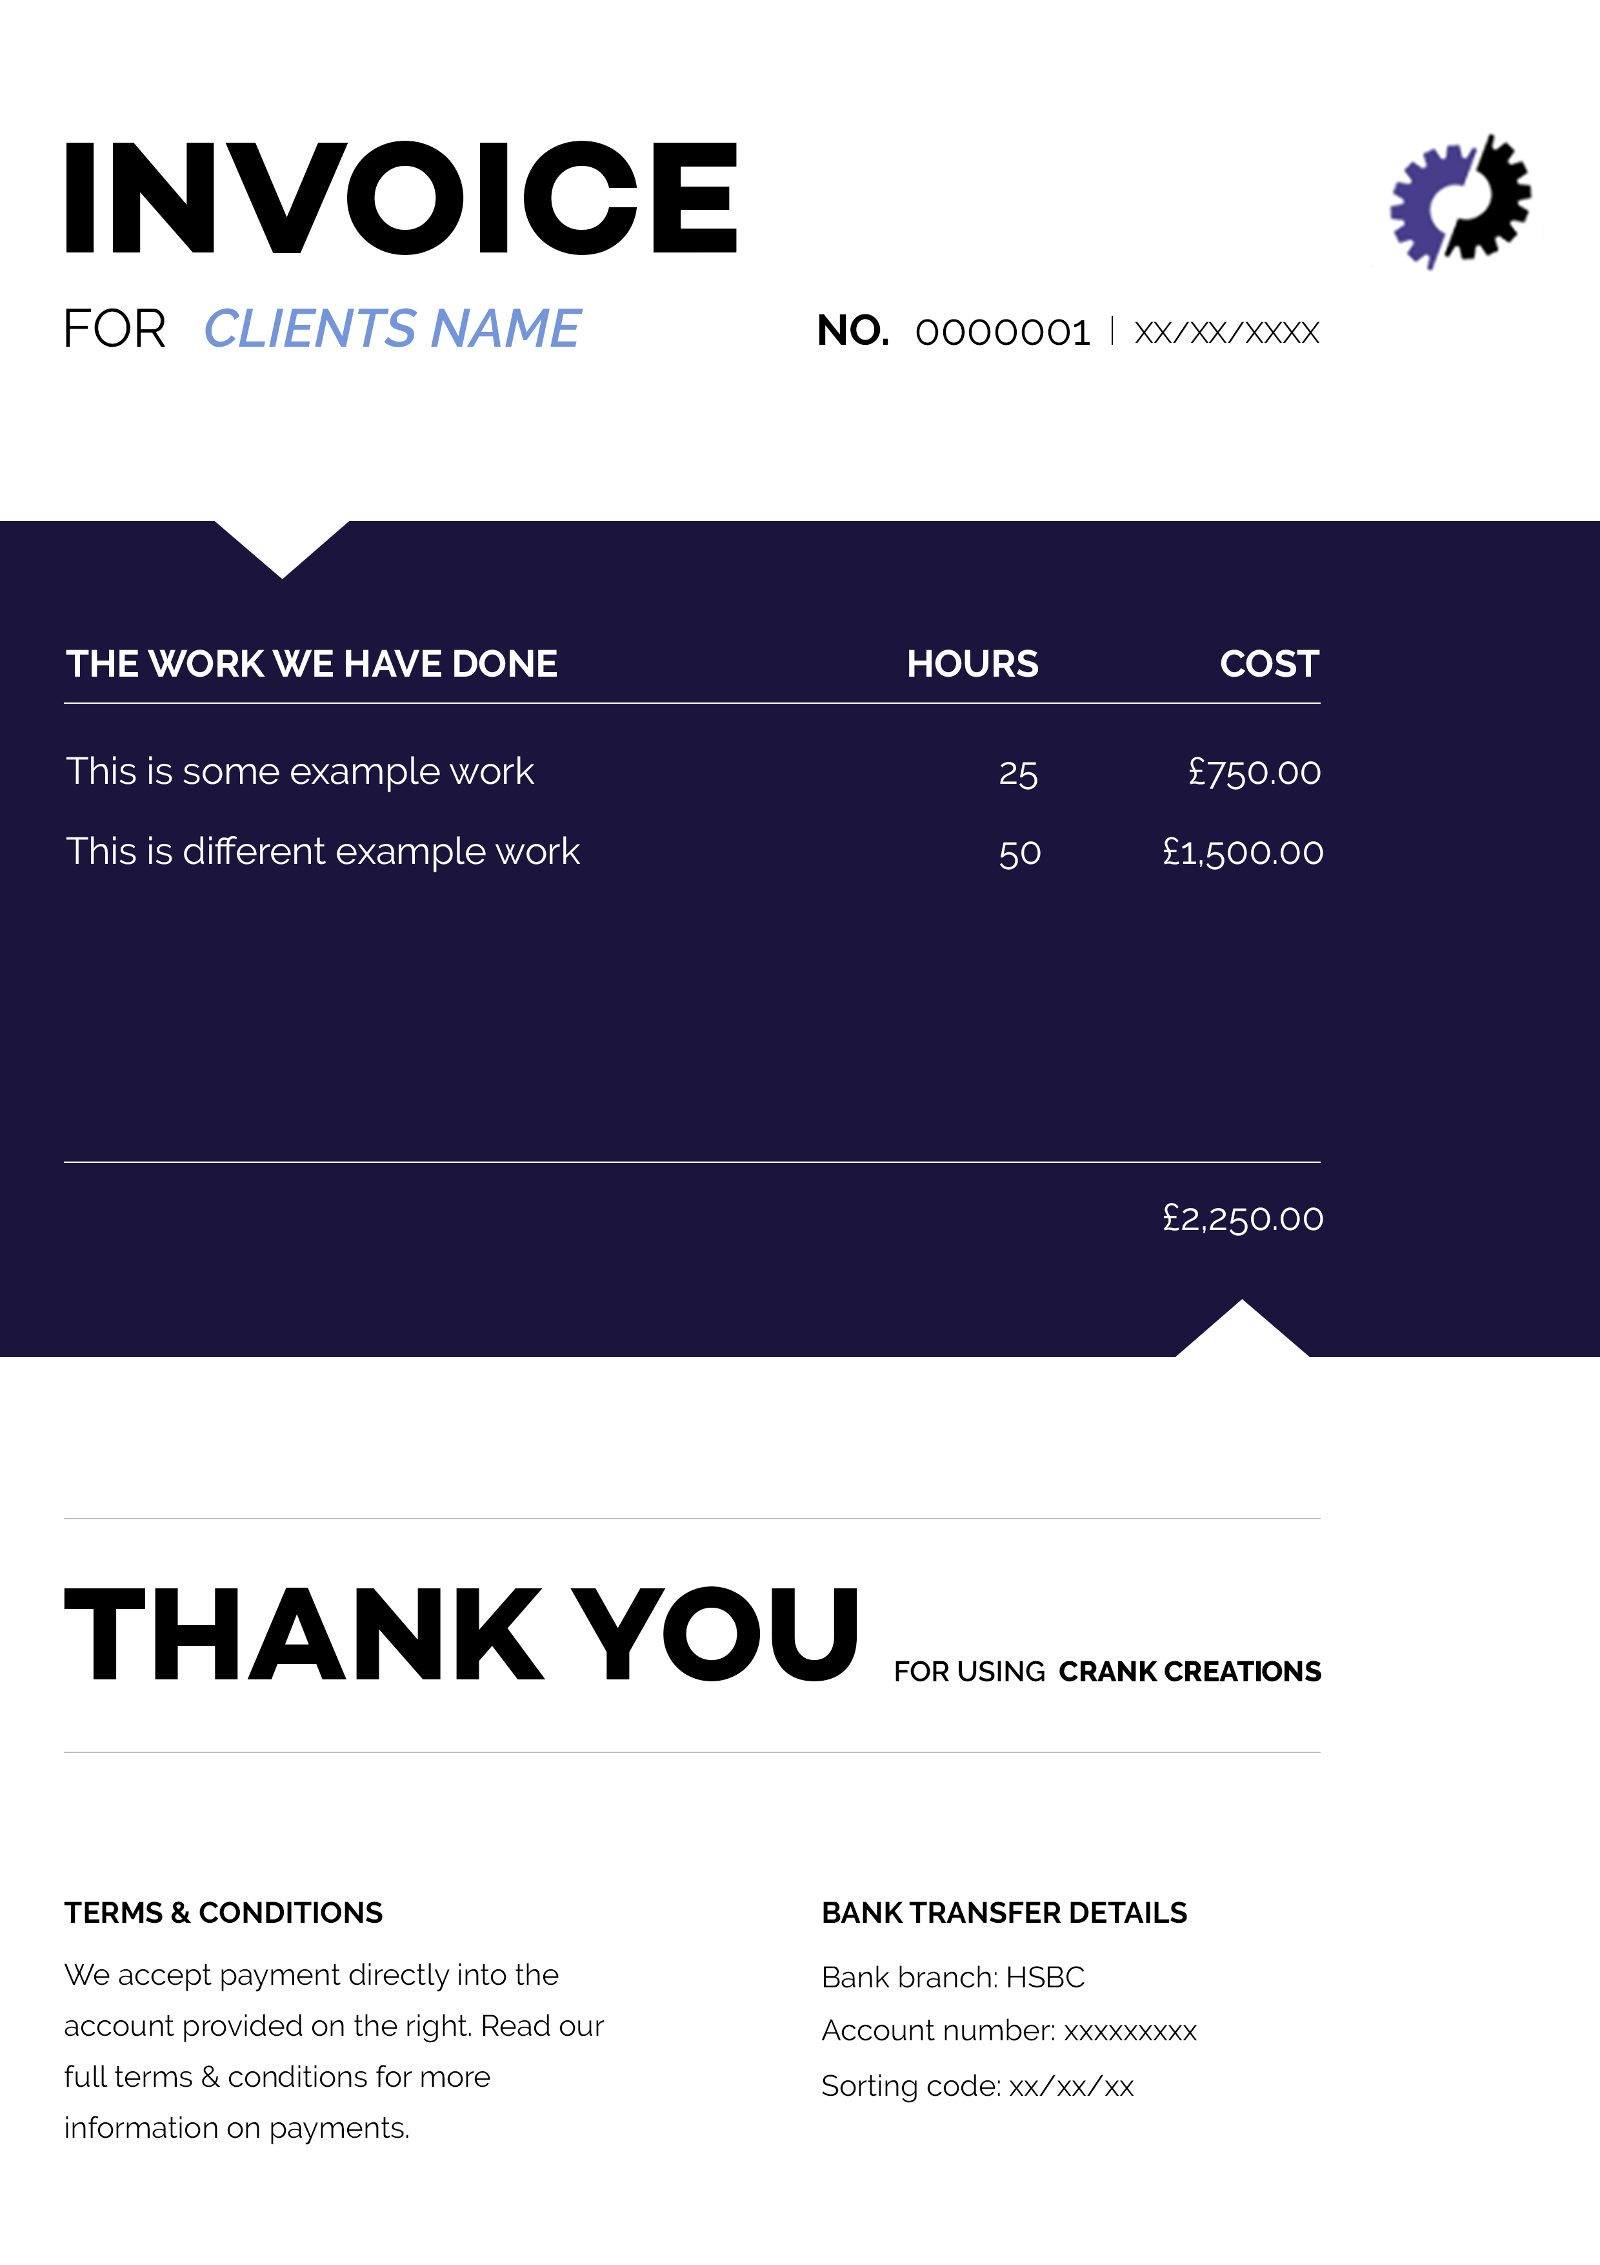

#### Payment packages

I created payment packages to allow clients to see the different types of websites they can receive. There are three package types, ‘simple’, ‘advanced’ and ‘ultimate’. ‘Simple’ is a single page website with no content management. ‘Advanced’ is a 2-6 page website with content management included. ‘Ultimate’ is an unlimited page website with content management, e-commerce and bespoke icon design included. The packages allow the user to have a visual representation of the features in a website, to make their decision accordingly. This makes it clear to clients the features they are entitled to, so they understand the limits of the package they have chosen. Using the price packages allows me to get an average price per package, and then customise depending on the project specifications.

## 3.5 Registering my Business

#### Sole trader vs. Limited company

When setting up a business it is important to register your company as one of the following: a sole trader, limited company or business partnership. Due to the type of company I have created, the two I focused on were sole trader and limited company.

A sole trader is a company run by a self-employed individual. Having a sole trader company does not mean having to work alone; you are able to hire staff accordingly. Setting up a sole trader company is the quickest and easiest method. Along with keeping records of your income and outgoings, the only other documentation is sending a yearly self assessed tax return. Because you are solely responsible for the company, in the unlikely event that a client sues you, you would be held personally liable to settle that claim.[50]

A limited company can be run by multiple individuals, and the company itself is responsible in it’s own right for everything it does. There are a lot more conditions that need to be met before you are able to set up as a limited company. These aspects include: having at least one shareholder and one director, an address for the company, producing a statement of capital, producing an article of association and producing a memorandum of association. Certain documents are recommended to be completed by a professional accountant; meaning annual spends from the company’s budget. Any profit made is owned by the company and then distributed accordingly (after tax). The company owns the money; meaning individuals have more personal protection in terms of financial liability. This means if your were sued as a company the company’s assets would be liable, and not your personal belongings.[51]

Due to the nature of my company I felt the likeliness of being sued was very minimal. On top of this I believe the documentation and potential hiring of an accountant, was unnecessary for this stage of the business. This is why I chose to set up my business as a sole trader company. I estimated in the next 2-3 years I would be changing my business from a sole trader to a limited company.

## 3.6 Joining an Association

#### Wired Sussex

Wired Sussex is a paid membership organisation located in Brighton & Hove. It helps digital, media and technology companies to create, innovate and grow. There are great investment benefits from joining Wired Sussex. Being part of an organisation with over 2000 companies relevant to your sector, allows you to easily network with potential partners and clients to help your business grow. They provide a projects board that informs you of any work relevant to your company that may have become available. This project board also advertises individuals you could potentially recruit to improve your business.[52]

Joining Wired Sussex was a fantastic investment to help my business grow faster. My membership gave me a great opportunity to improve my business and gain work. It also provided me with a platform to network with other professionals, to keep up to date with current affairs and new developments in the digital world.

## 3.7 Insurance Policies

#### Professional indemnity insurance

Professional indemnity insurance (PI insurance) is a type of liability cover. It is designed to protect individuals or businesses against claims made by clients, for loss or damage due to negligent advice or services.[53] PI insurance covers my company in the unlikeliness of the client being unsatisfied with the product and asking for compensation. I have chosen not to use this insurance, until my company expands and will have multiple projects in production at one time. This is because multiple employees will be working on projects simultaneously, so I will be unable to ensure mistakes are not made on each project.

#### Property insurance

Property insurance is a policy that allows reimbursement to the owner if their equipment is affected by: fire, water, theft, loss, accidental damage or a natural disaster.[54] By having property insurance it will reduce the impact my company will take financially from loss of equipment. It will also help cover compensation for clients if their information/work is lost. I will be looking into using property insurance at the early stages of my company. I will use one of the cheapest plans as the equipment I own is very minimal, which means I will not need expensive coverage.

## 3.8 Owning Intellectual Property

Intellectual property (IP) is every part of a product or service that enables people to earn recognition or financial benefit, from what they invent or create. This is through patents, copyright and trademarks.[55] When creating a business it is important to understand IP. If either the client or anyone at your company breaks the law IP is protected under, the penalty could range from a polite letter (asking the content to be removed) to a jail sentence.[56]

My companies IP will be added to the terms & conditions each client receives. The client must understand and accept these before the project can proceed. I will be kept as the author and owner of IP for the website code created for each project. This is to allow small elements of code to be reused across projects, such as a contact form. Copyright, Design and Patent Act 1988 is the current UK copyright law, that gives creators of artistic work the right to control the ways in which their material may be used.[57] The IP of designed assets for a client will be owned by my company, to allow them to be displayed on websites as examples of work. As the designs will be bespoke I will ensure the assets are not reused for other projects in the terms and conditions.

## 3.9 Site Accessibility

When designing a website it is important to focus on making it accessible for all users. Catering for users with disabilities will prevent losing a percentage of your target audience. The Web Content Accessibility Guidelines (WCAG) website, was invented to create web content that is accessible to people with disabilities. The WCAG is a technical standard that uses twelve guidelines, to give your web page/application a testable success criterion (A, AA or AAA).[58] The twelve guidelines are broken into four different principles: perceivable, operable, understandable and robust.

### 3.9.1 Perceivable information and user experience

The web page/application must be presented to all users in a way they can perceive it. There must be no information on the page that a user would find difficult to read/understand. The perceivable principle has four guidelines to understand and implement.  
  
Text alternatives for non-text content

This is ensuring images; videos, audio files and functions are labelled with text to help the user understand it. For example a search button will have the word “search” instead of a “magnifying glass”.   
  
Captions and other alternatives for multimedia

Users that cannot hear audio or see video need alternatives to engage with. For a user that is unable to see, the video should include audio descriptions that explain important visual details in the video. Users that are unable to hear should be able to see sign language interpretations for the audio content.  
  
Content can be presented in different ways

The content of a website can be presented differently to improve the overall accessibility of your web page/application. This can be done by: allowing the user to increase/decrease the size of text, being able to change the colour scheme or any other change to the style to facilitate the users needs.

#### Content is easier to see and hear

Content is made easier to see and hear by: being able to pause, stop or turn off audio to reduce the chance it interferes with assistive listening devices, having a sufficient background and foreground colour contrast, alternatives to colour being the only way of conveying/identifying information or having resizable text.

### 3.9.2 Operable user interface from a keyboard

The users must be able to effortlessly operate the web pages/applications interface. If there were operations that proved too difficult for certain users to complete, this would be considered a badly integrated user interface. The operable principle has four guidelines to understand and implement.  
  
Functionality is available from a keyboard

Many users do not use the mouse when interacting with websites. To make the website accessible for these users, the content must all be accessible with the keyboard alone. Users might be using: keyboards with ergonomic layouts, on-screen keyboards, or switch devices. By having the content fully accessible to a keyboard it would improve the user experience.  
  
Users have enough time to read and use the content

Some users may need more time when reading/using content. To ensure all users gain the full experience of a website, all content that changes should be viewable for an extended period of time. Ideally there should be no time limits for reading/completing contents or tasks.  
  
Content does not cause seizures

Some users may have photosensitive eyes that when exposed to flashing lights/images could cause seizures. To ensure this is not a problem, it is important to avoid using any flashing content.  
  
Users can easily navigate, find content, and determine where they are

A website that is well-organised and laid out helps users to navigate throughout effectively. The actions that could be taken to improve how users navigate through a website are: having clear page titles, multiple ways to navigate to each section, clearly labelled pages and the purpose of a link is clear.

### 3.9.3 Understandable information and user interface

The content and operations on the website must be easily understandable to all users. By having content that is beyond the understanding of users, would increase the chance of them navigating away from the website. The understandable principle has three guidelines to understand and implement.  
  
Text is readable and understandable

The content on a website must be readable and understandable to the broadest audience possible. The content must also be understandable for assistive technology.

#### Content appears and operates in predictable ways

Many users rely on predictable interfaces that will stay consistent on each page. By ensuring the functionality of your website is consistent will help users feel comfortable when navigating though it. If the website is not consistent it could cause confusion to the user.   
  
Users are helped to avoid and correct mistakes

It is important, when possible, to help users avoid making mistakes when interacting with the website. If mistakes are made then it is equally as important to clearly label how the user can correct those mistakes. For example when a user is filling in a form, the instructions should be very descriptive. If an error is made on the form, the error messages and suggestion for correction should be clearly visible.

### 3.9.4 Robust content and reliable interpretation

By making the content of a website robust it means the users are able to easily access the content, even if technologies advance. Assisted technologies such as text-to-speech programs and audio descriptor programs are constantly evolving. By having a robust system that allows content to be accessible as these technologies evolve, will greatly increase your websites overall accessibility. The robust principle has one guideline to understand and implement.  
  
Content is compatible with current and future user tools

When creating your content you should ensure it is compatible with: all browsers (including older versions), assistive technology and other user agents (a software that is acting on behalf of a user).[59] By meeting this requirement it will help maximise compatibility with current and future user agents.  
  
Conformance levels

The Web Content Accessibility Guidelines (WCAG) are divided into three conformance levels: A, AA and AAA. These levels are based on the design, visual presentation and overall accessibility of the web page/application. The higher level it is, the more restricted you are with your designs. This is because certain colours, layouts or fonts may be unreadable to certain users.   
  
A **Level A** success criterion focuses on having a high impact on a large user population. This usually means not focusing on one type of disability. This level has the least impact on design for a web page/application.

A **Level AA** success criterion meets all of the target users level A reaches, but also aims to make the accessibility easier for specific user populations. This level may have impact on design for a web page/application.

A **Level AAA** success criterion meets all of the target users level AA reaches, but also focuses on improvements for the user population that have the most severe accessibility problems. This level will have a large impact on design for a web page/application.  
  
Accessibility for my website

The accessibility of a website is very important when trying to cater for the broadest audience possible. After researching about The Web Content Accessibility Guidelines (WCAG), I realised that alterations needed to be made to ensure a large user population was able to use my company website.

The twelve guidelines stated by WCAG are key when designing the accessibility to your website. The main guidelines I focused on were: text alternatives for non-text content; content presented in different ways (increasing size of text and different colour schemes); users can easily navigate, find content, and determine where they are; text is readable and understandableand users are helped to avoid and correct mistakes. By focusing on these guidelines it greatly improved my company website’s accessibility.

Level A – Level AA was the conformance level I aimed to achieve. This was because it greatly increased the accessibility to a large user population, whilst keeping design restraints to a minimum.

# 4. Business Plan

#### Business plan vs. Start-up plan

It is important for a company to have a document displaying their plans and goals for the future, and how they will achieve them. The two pieces of documentation I will be comparing, are a business plan and a start-up plan.

Another type of approach I researched was a business model canvas. The business model canvas works as a step-by-step business planner that you are able to add to when necessary. It is commonly used at the first stages of your business and focuses on sections such as: customer relationships, revenue streams, customer segments and value propositions.[60] I chose not to use this technique because the time spent creating it compared to the information gained, would not be justifiable.

A business plan is a formal document that states a company’s goals, reasons they are attainable and plans for reaching them. It can also contain background information about the company and team. A business plan is a large document

(average 20-40 pages) that is used to optimise growth and development by prioritising plans. However businesses that have not created one from the start commonly do when applying for business loans or investments. [61]

A start-up plan (also known as a business plan canvas) is used to analyse an idea you would like to start a business with. It encourages you to think of the nine key components of an idea, so you can decide whether you want to pursue it. It is also useful for those who have already started a business, as a concise business plan.[62]

From my research I decided to choose a start-up plan for this stage of my business. I will be creating a business plan at a later stage, however I believed a start-up plan is more than sufficient to portray the goals I am planning to achieve.   
  
Vision

In 3-5 years I predict that my company will be working from an office located in Brighton. Crank Creations will be a limited company that has 4-6 other employees working on separate projects. This will maintain the company’s efficient and successful reputation. Crank Creations will be a respected website design and development company, that focuses on producing high standard websites to satisfy each client. The company gains a large amount of work through the recommendations of satisfied clients. The individuals that work at Crank Creations will be polite, helpful, disciplined and knowledgeable, to make the clients project a straightforward and enjoyable process.   
  
Products and services

At Crank Creations we produce reasonably priced, high-quality, mobile responsive websites. We also maintain exceptional client and employee relationships. Crank Creations aim to plan and produce user-friendly, modern and sophisticated websites based on the client’s wants and needs.  
  
Benefits and impact

Crank Creations will produce bespoke websites for each client’s individual business/service. This will help improve their reputation and company image, to enable them to branch out. It will increase the size of their company, which will also allow them to gain new employees and customers. It will make it easier to display their company information and the message they are trying to convey on an accessible platform to all.

#### Customers and competitors

Crank Creations’ target customer can be anyone. As a company we look to be flexible but always keep the client in mind. We will work with individuals, self-employed businesses and corporate companies.

For my competitor analysis I chose to analyse four different companies. Two of these were website design & development agencies, the other two were freelance web developers.

**Build By Buffalo[63]**

Build by Buffalo are a Brighton & Hove based website design and development company. They were established in 2006, and have grown drastically since then.

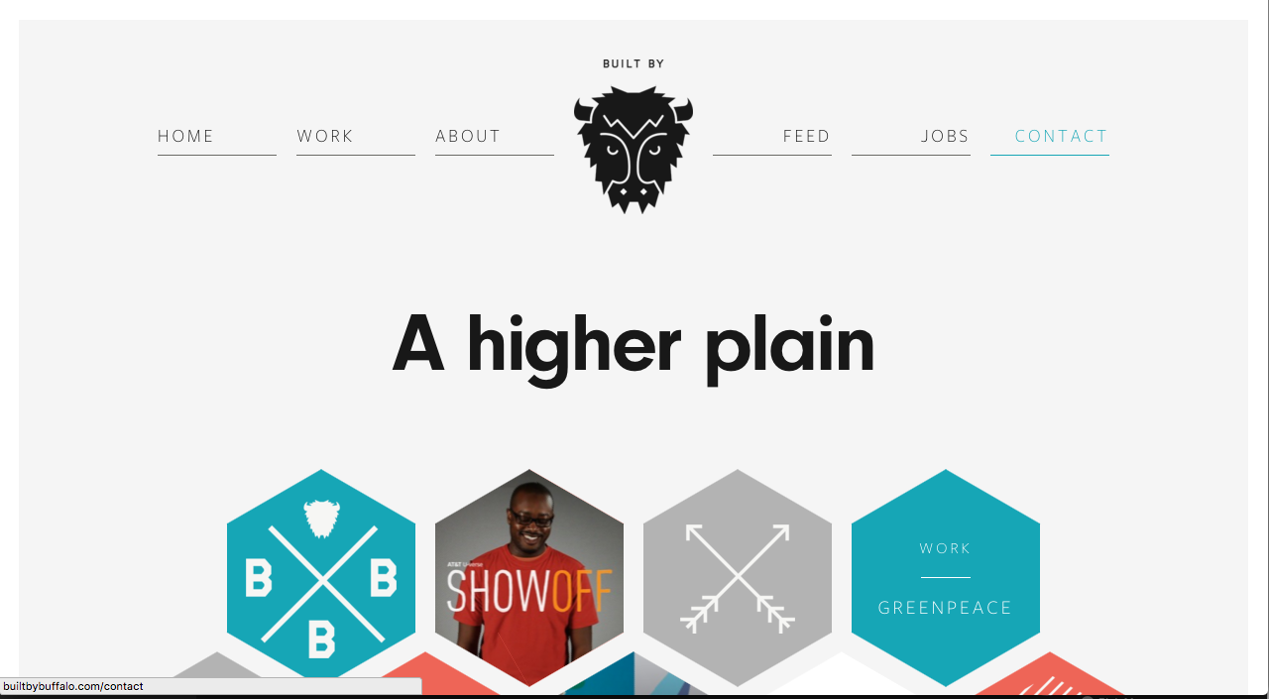

Built by Buffalo’s brand is effective and memorable. They show the client the high level of service they provide along with their range of skills. The tone of the website is very modern and relaxed, but maintains a strong sense of professionalism throughout. This gives you the impression that communication with them will be easy and enjoyable, whilst still upholding a trustworthy work ethic and standard.

**Code 7[64]**

Code 7 is a website design and development agency located in Brighton & Hove. They were established in 2007 and have expanded since then. They were ranked 1st on Google when searching for ‘website design and development in Brighton’.

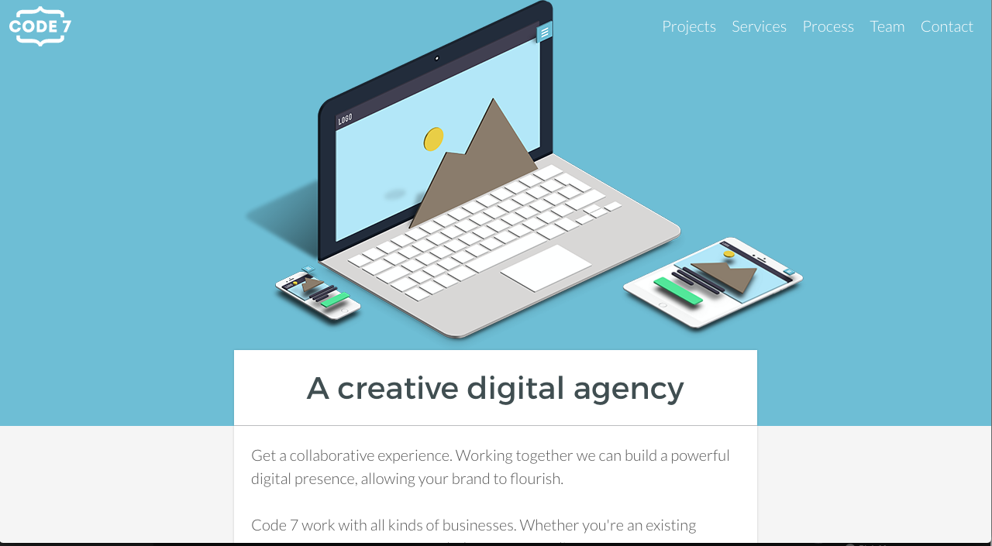

Code 7 are one of the leading website design & development agencies in Brighton & Hove. From the reviews I have read[65], Code 7 produce high quality work that satisfies their users needs. On their website they display impressive testimonials for specific projects.[66] As a user, the design of their website does not appeal to me. However they have strong content, impressive usability and enough respectable work in their portfolio to make them a successful business.

**Comparison analysis**

Built by Buffalo and Code 7 are very respected digital design & development agencies In Brighton & Hove. They are direct competitors in this sector and both advertise their company as creating great websites with usability in mind. When analysing these two agencies I could see they both used different approaches to attract clients. Built by Buffalo use a clean and minimalistic style for their design and content. Code 7 uses a busy design with lots of informative content throughout. Both have their advantages. Having a clean minimalistic design looks pleasant and allows the user to navigate through the website with ease. Having concise content means the user is more likely to contact Built by Buffalo regarding general questions. This will establish the first point of contact that could turn into a potential client. Having more informative content on the website can also be advantageous. The user contacting will be a stronger potential client, as they would have learnt more about the business and be interested in the services provided.

To conclude, I have analysed two Design and Development agencies. I was inspired by Built by Buffalo’s website and will take this into consideration when designing my own company website. My website will feature a minimalistic design with subtle colours and a single deep accented colour. I will only use relevant, concise and informative content in order to attract strong potential clients, interested in my work.

I have created a table to show how I have compared and contrasted Built by Buffalo and Code 7 using a scale of 1 to 10. The results have been created from the information I gave in the competitor analysis and displayed in a table and radar chart. I did this to show a visual representation of my ratings for the competitor analysis.

|  |  |  |
| --- | --- | --- |
|  | **Built by buffalo** | **Code 7** |
| Quality of branding | 9 | 7 |
| Structure | 7 | 7 |
| Content | 6 | 7 |
| Landing page | 7 | 5 |
| Logo | 7 | 7 |

**Design Superheroes[67]**

Design Superheroes is a freelance Ltd website design and development company located in Brighton & Hove. It is a highly ranked website on Google when you search “Freelance designer & developer in Brighton”.

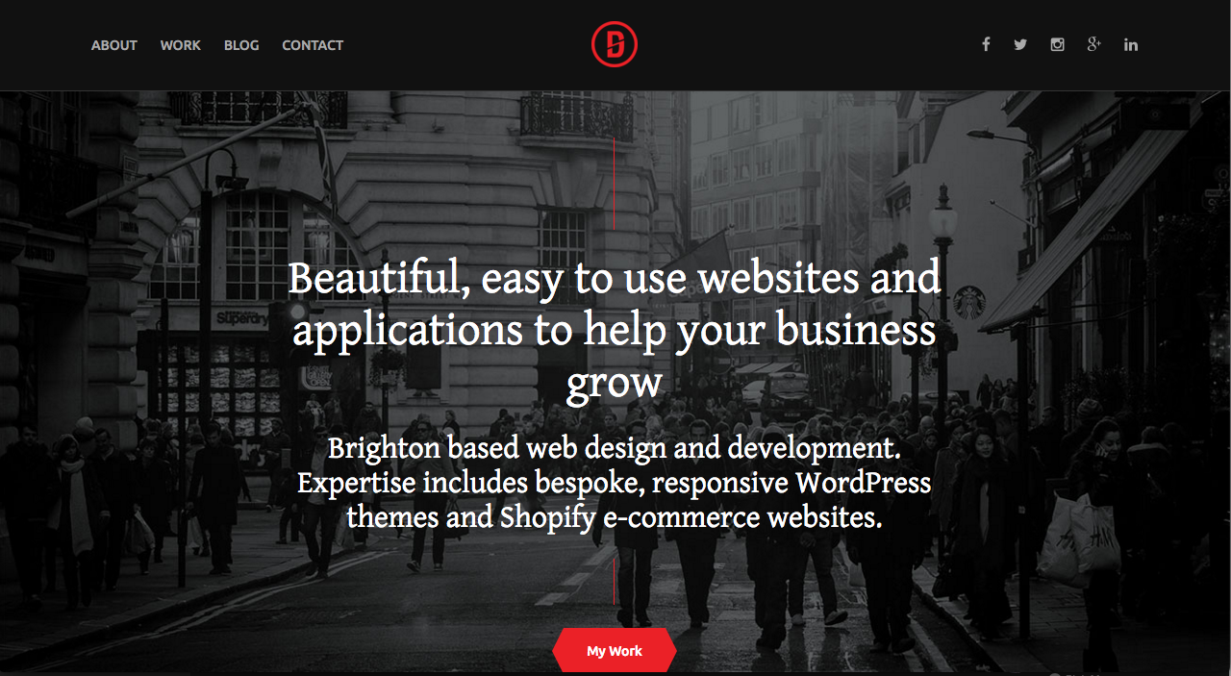

Design Superheroes is a brilliant example of a freelance website design and development company. The attractive, eye-catching design is appealing but also sophisticated. The website is straightforward to navigate through, creating a pleasant user experience. The development is clean, efficient and responsive. Most importantly the branding and content is very personal and unique. This gives you the sense that working with this company will be an enjoyable experience.

**Roweena[68]**

Roweena is a freelance website design and development company in Brighton & Hove. They rank 1st on Google when searching “Freelance website design and development Brighton”.

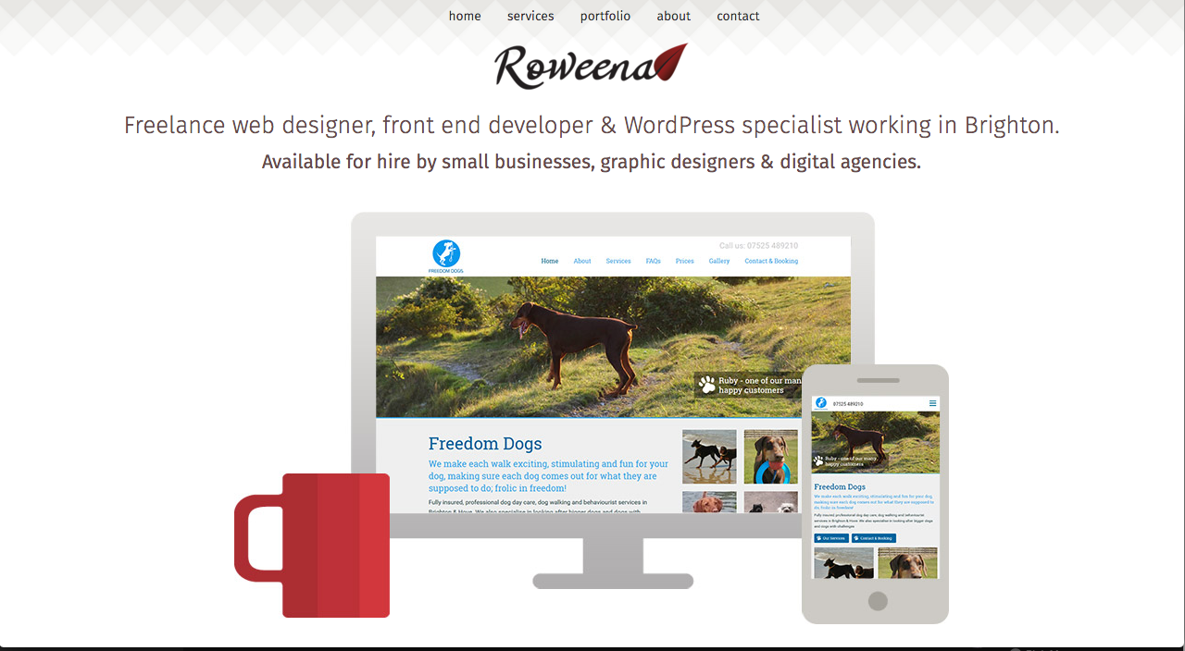

Roweena is a pleasant freelance website that displays it’s content clearly. I personally dislike the design aspects of this website as it lacks character and originality. The content is concise and explains their services, however it does not portray any personality of the individual or company.

Both freelance companies have different approaches to appeal to their target audience. Their websites are structured differently, but individually very well. They each have concise content with very different messages being interpreted. Both feature a simple and minimalistic design, however I felt Design Superheroes’ website had better flow and more personal content that was easier to relate to.

In conclusion I learnt a lot from analysing these two freelance companies. I gained a better understanding of how a minimalistic design can flow, and stand out better than others. This is achieved by using 3-4 colours, and making the copy, icons and buttons a vibrant colour in contrast to the minimalistic background. It is important that the structure of my website is easily accessible and the usability is simple and pleasant. This will be tested once my business website has a prototype to user test. An important aspect I learnt from this analysis is the personalisation of a freelance website. After viewing Design Superheroes it influenced me to make my business website individual and unique. It is important to help a client relate to your website through your content, personality and values.

The information gained from this freelance individual competitor analysis, enabled me to compare the two freelance companies using a scale of 1 to 10. Below I have displayed the information gained in a table and radar chart, to allow users to have a visual representation of my results.

|  |  |  |
| --- | --- | --- |
|  | **Design Superheroes** | **Roweena** |
| Quality of branding | 9 | 4 |
| Structure | 7 | 6 |
| Content | 9 | 7 |
| Landing page | 8 | 6 |
| Logo | 7 | 7 |

#### Marketing activities

Crank Creations company website will display all of the relevant information needed, to ensure a client will be sufficiently informed of our services and products. The SEO will be optimised to improve Google searches, to help clients find my website when searching for website design companies. Marketing on social media extends the reach of your services to wider platforms. This will result in engaging more potential clients. Testimonials received from successful projects, will also help other clients see the standard of service we provide.

#### External environment

I have decided to create a PEST analysis diagram for my business. This is to understand the environmental factors I need to take into consideration for my current market. It is a useful strategic tool for understanding market growth/decline, business position, potential and direction for operations.[69]

|  |  |
| --- | --- |
| **Political**   * Government stability * Government policies * Future legislations * Regulatory bodies and processes * War and conflict | **Economical**   * Inflation * Unemployment * Monetary issues * Increase/reduction in labour costs |
| **Social**   * Attitudes to work and leisure * Health and lifestyle * Social mobility * Clients attitudes and opinions * Change in demographic | **Technological**   * New technological discoveries * Rates of obsolescence * Rates of development * Licencing/ patents * Research showing new current web trends |

#### Operations and risks

In the early stages of my business I will need a computer and telephone to successfully run Crank Creations. I will be working from home and set up as a sole trader. As the business expands and evolves, the amount of equipment needed will increase and my facility and legal status will change. I will be set up as a limited company and purchase an office to work from. The equipment needed to run a business would be increased to compensate for the: change in workspace, increased number of staff, larger projects and evolutions in technology e.g. new computers.

#### Me and my team

Initially I will carry out all of the company tasks. Once the business begins to grow, staff will be employed to help manage the increasing number of projects. Those roles consist of: managing finance, designers, developers, marketing of the business and initial communications to source projects. In total a team of 4-6 would be ideal for the successful running of my business.  
  
Costs and income

I created a cash flow forecast and survival budget to accurately estimate my income, and outgoings for the next 6 months. By creating this document I was able to plan in advance for any shortage of money, to prepare myself if it were to happen. By rounding up your expenses and rounding down your income it can allow you to prepare for the worst-case scenario. There is a difference between a cash flow forecast and a survival budget. A survival budget is focused on expenses for your personal life, for example: meals out, clothing and food shopping. A cash flow forecast focuses on the expenses that are compulsory for running a business, for example: living accommodation bills and rent.

**Cash flow forecast & survival budget**

*The table below is a combination of a cash flow forecast and a survival budget.*

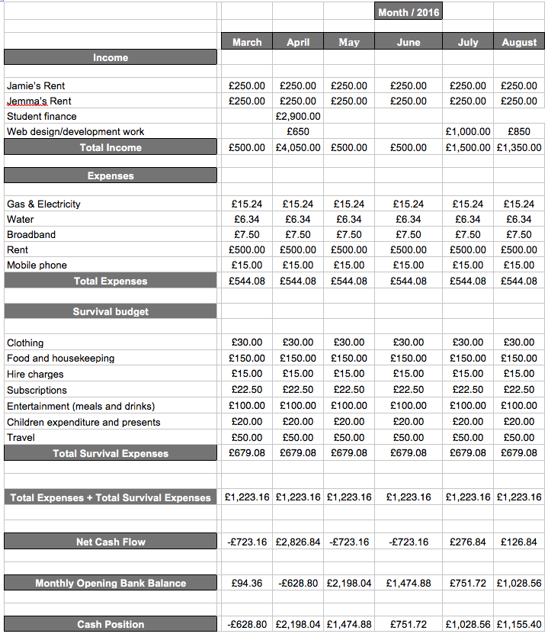

# 5. My company

## 5.1 Company name

#### Majime

When choosing a name for my company I wanted one that was unique and memorable. Majime is a Japanese term that signifies being responsible and reliable, and is also an anagram of Jamie M.[70] A problem I found with Majime was the difficulty in pronouncing and spelling it. This would be problematic when explaining your business to a client, who may later be unable to remember how it is spelt.  
  
Crank

I decided to change my company name from Majime to Crank Design & Development.A crank is most commonly known as a piece of equipment that fits between two parts of machinery to create movement. This is an analogy of my company’s work. We will act as the “crank” between the client and final product. “Creations” was added to replace “Design & Development” as I wanted to condense the logo. The word creations has artistic, imaginative and development connotations. The final name decided for my company was Crank Creations. Crank Creations is a unique and concise alliteration that is memorable and understandable.

## 5.2 Company logos

Below are the final designs for each company name along with the changes made between each one. (*For the full logo design process see Appendix 1.1)*.

5.2.1 Majime  
I wanted the logo for Majime to be clean and easy to read, with a vibrant coloured icon in the logo. This is to allow the shorthand icon to be recognised on it’s own without the need for the title.

#### Final design



### 5.2.2 Crank Design & Development

I wanted to use a cog icon to represent Crank Design & Development as the shorthand logo. This will reinforce the company name by using a relevant icon image. The word Crank in the logo is the largest text, this is to attract the attention of users to easily recognise the company name.

#### Final design



### 5.2.3 Crank Creations

The style of the logo was very similar to Crank Design & Development. I decided to keep the font lowercase with the first letter of each word capitalised. This was to make it easier to read and more appealing to the user.

#### Final design



## 5.3 Company colour scheme

During the creation of the company logo I discovered that I wanted to use the colour blue or purple as the accented colour for my company. Colour’s psychological meanings differ depending on the person, but there is a general consensus for certain colours. Blue represents creativity, imagination and wisdom. Purple represents trust, dependability and strength.[71] I decided to choose purple for the logo, however I still wanted to use blue within my company as both colours compliment each other. I created a colour palette to give myself a visual example of the colours that will represent my company.



The colour scheme is modern, minimalistic and sophisticated. From doing the competitor analysis I realised it was important to have a consistent and eye catching colour scheme throughout.

## 5.4 Company Layout Ideas

The layout of a website is very important. The user must be in mind throughout the whole design process, to ensure the website is user friendly. If a user cannot operate the website as intended, that user may choose to navigate away from your website. (*For the full list of layout designs see Appendix 1.2).*

## 5.5 Company Assets

### 5.5.1 Icons

I created bespoke designs for each icon used on the company website. Each icon must look unique and attractive, whilst still portraying the section it covers.  
  
Strategy

When creating a strategy for a project, you must plan each operation well. If a task is poorly planned, it could potentially hinder future tasks that may depend on it. This reminded me of building blocks. If the foundation is poorly executed it will only cause trouble as the blocks stack higher.



#### User experience

The user experience of a website is how well the user interacts with it. For the icon I decided to create a three column wireframe of a website. This demonstrates a clean interface wireframe that would be easily accessible for users.



#### Design

The design of a website is everything visually displayed on it, such as: colour schemes, graphical designs and the layout. When creating the icon for design, I thought of a paper aeroplane. This is because everyone has his or her favourite design for one. Although some are more commonly known, creating paper aeroplanes heavily revolve around personal preference. This is like designing a website.



#### Development

The development of a website is the code used to produce everything seen on the page. I decided to make the icon for development two brackets and a forward slash. This is a symbol commonly used in HTML (the mark-up language used to display a website).



#### E-commerce

E-commerce (electronic commerce) means commercial transactions conducted electronically on the Internet. When creating an icon I chose to design a shopping cart. This is because it is a widely acknowledged icon to represent shopping, whether online or offline.



#### Content management

Content management is the way any content is organised. In terms of websites it means the storage (hosting) of the code and assets. This is most commonly done on a content management system. This is the reason I chose to use an abbreviation of the term content management system as my icon.



### 5.5.2 Illustrations

For certain pages throughout the website I created bespoke illustrations. Some of the illustrations were animated by: a gif animation, CSS3 animations or with JavaScript. The illustrations I created had a consistent branded theme throughout, reusing the Crank Creations symbol (a cog) and colour scheme.

*(For the full breakdown of each illustration, see Appendix 1.3).*   
  
Homepage

On the ‘homepage’ for Crank Creations website I created two illustrations. One is a gif animation with CSS3 animation around it. The CSS3 animation is styled with Animate.css.[72] The other is a static illustration.

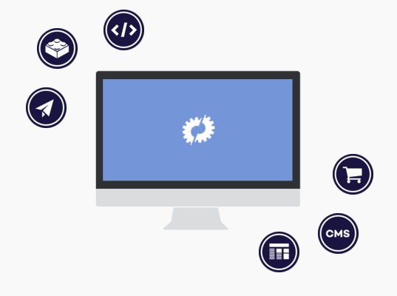



#### Contact page

On the ‘contact page’ for Crank Creations I produced a simple message sending gif animation, to make the page more exciting.

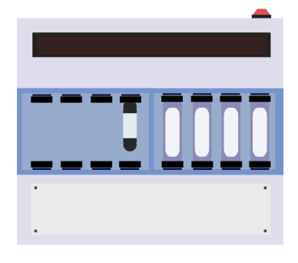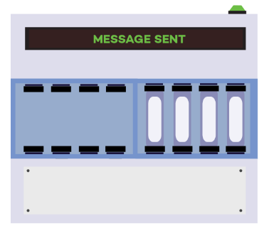

#### About page

On the ‘about page’ I created two simple illustrations. One was a four-section cog that once clicked, displayed the four key points that make up a Crank Creator. The other was a simple heart with a cog in the middle. Both use the Crank Creations colour scheme.

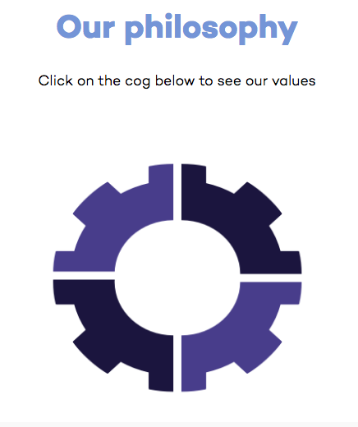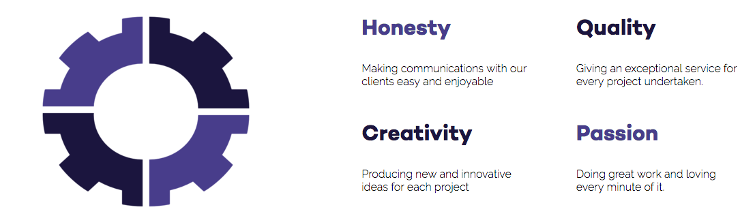



## 5.6 Company Business Cards

Company business cards are a fundamental way to market your business, through person-to-person networking. When designing the business cards it is important to adhere to your company’s branding. You must display all the relevant information a client will need to find out about you and your company.

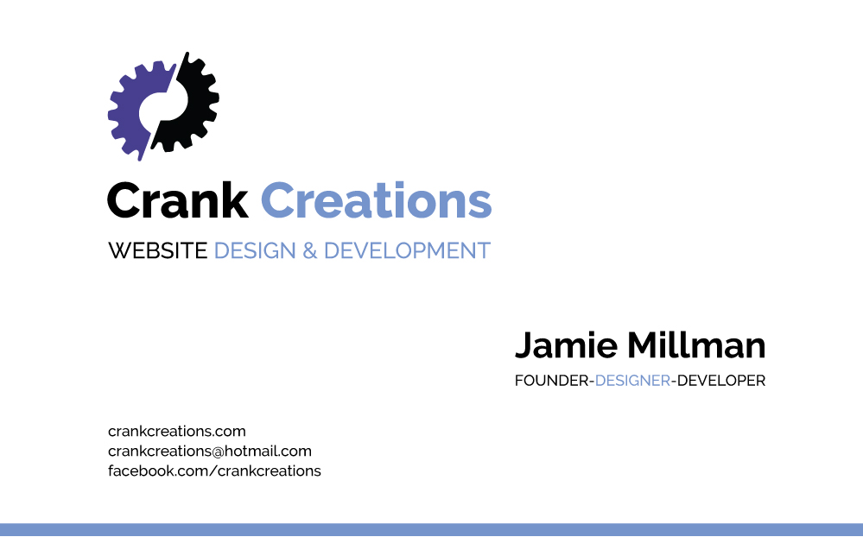

## 5.7 Company fonts

#### Heading font



The font used for the heading elements, on the company website is called Campton. Campton is a clean san-serif font that looks sophisticated in bold or light font weight. For the heading elements Campton was used specifically in the bold format. This was downloaded for free from the website font fabric.[73] I then converted it into a web font through font squirrels web font generator.[74] Font squirrels web font generator is a service provided by font squirrel. It allows users to convert a standard font format such as .ttf, .otf and .eot files into a web font. This allows standard fonts to be used in the development of websites, by creating a HTML and CSS file that you copy into your code. Certain fonts are blacklisted from this service, so you must make sure the font can be used for web before converting it.

#### Body font

****The font used for the body elements on the website is called Raleway. It is a simple, thin and clean san-serif font that works well as a websites body font.

This font was used from Google web fonts.[75] Google web fonts is a website that allows you to choose from a large selection of fonts to add to your website. Once you find your desired font, you can choose to either: use HTML code to put into your document, import the font using Sass/Less or add it using JavaScript. I imported mine using Sass because it was the neatest and most efficient way to implement it. The HTML code must be added to every HTML page that requires the font, whereas Sass is able to import it once for the single style-sheet. Once it is correctly linked to the website, you add a small line of CSS to each element you want styled as that chosen font.  
  
Font stack

When using a downloaded font it is important to have fall-back web safe fonts, in case the users browser is unable to render/use it. This process is called a font stack. If the HTTP request for the font file times out, it will corrupt the font, rendering it useless at that time. This is why having web safe fonts as a fall-back is important, to ensure all users have a similar experience on the website.  
  
Testing font across browsers

Once the website was finished, I began testing across all browsers to see if the fonts were rendering correctly. I was able to download the latest versions of: Google Chrome, Mozilla Firefox, Safari and Opera for testing purposes. My fonts all rendered correctly in these browsers. I was unable to download Internet Explorer or test on older version browsers. Therefore I used a website called Browserling to help test my fonts on these platforms.

Browserling is a web application that allows you to enter your website’s URL, to virtually run it in your chosen browser. I checked my company website in every browser up to 5 versions old. This was to ensure clients, that do not regularly update their browsers, still get a similar user experience. It also allows you to test different versions of android OS browsers.[76]

# 6. Evaluation

To conclude this report, I will now evaluate the three main stages of creating my business: research, products and marketing. I am going to explain what I learnt during these stages and outline the strengths and weaknesses from them.

## 6.1 Analysis of the Research

Before creating the business website and business cards, it was imperative to have done extensive background research. This included competitor company analysis and common trends in the web industry. This was to ensure the decisions I made were justified by the research I had compiled.

From evaluating the research stage I was able to see which aims were met, and which ones were not. This allowed me to judge the success of each aim, and to reflect on how I would have improved them.

By analysing the current state of the digital industry, I was able to improve my knowledge of the sector. I learnt from interesting articles focusing around the creation of a business, such as the Lean Startup and The Brighton Fuse. I was able to apply the knowledge I had gained from the digital industry and business approach theories. This helped me get a better understanding of the website design & development industry.

During the research stages I attended lectures, events and meetings that would help throughout the process of this project. These included: typography events, business start-up meetings, design lectures and a lecture on information architecture. From attending these it allowed me to gain a better understanding of different topics revolving around my industry. It also improved my networking skills at professional events.

I then contacted respected digital agencies in Brighton and London to ask about the tools they regularly use. I gained a strong understanding from the information received by the digital agencies and my personal research. From this I was able to choose the correct tools for my specific company.

I then researched the accessibility of websites. The twelve guidelines stated by The Web Content Accessibility Guidelines (WCAG), helped me understand the necessary steps needed to improve the accessibility of a website. From the twelve guidelines I selected the points that gave my website a basic accessibility level, without impeding the design too much.

The knowledge I had on the inner workings of a business was very limited prior to this project. I am now competent in knowing the correct method of running a small web business. The tasks I have carried out include: setting up an insurance policy, a legal status, terms & conditions, a business start-up plan and common operational procedures.

There are certain aspects that I would have done differently during the research stages, if I had more time and prior knowledge. I would have asked more companies about their toolkits. Three companies responded to my emails and they reinforced a lot of the ideas I originally had from my research. I could have increased my company research scope to worldwide, to get a broader understanding of the tools and techniques used globally.

## 6.2 Analysis of the Products

My business website, client websites and business cards, were the deliverables I created during this project. I produced these from the knowledge I gained from my research and it guided the decisions I made when designing and developing these products.

I will be able to evaluate how my skills have improved through the deliverables of this project. I have learnt how to use several computer languages and programs, whilst creating my business website, client websites and business cards.

When creating the company website, it was important for me to have a thorough understanding of the tools being used in my company’s toolkit. I have not previously used any of the tools listed in my toolkit (excluding JavaScript and jQuery). This made it challenging to gain a deep understanding of so many different tools. Git was used throughout the whole project to save versions of my work online. Using the command line to access Git was challenging to initially grasp, however it’s a beneficial skill to have learnt for future tasks. Sass was used for the styling of my website. It improved the structured code making it easier to manage and edit. Gulp was used to run and improve the tasks used by Sass. Both Sass and Gulp were intricate languages to install, run and use, as I had never used them before. The tasks were run through the terminal, further improving my skills with it. Learning to create a custom grid was an important task, to ensure the layout of my website was structured correctly with ease. It was a simple task of creating CSS elements with specific widths to call as classes in the HTML. Using Normalize.css allowed my website to preserve the browser default styles, to make it more consistent throughout. It was a straightforward task of referencing the CSS file into the HTML document. However I edited certain styles within the document to fit better with my website. My knowledge in JavaScript and jQuery improved drastically. This will make me more capable during development for further projects. I did not have time to implement Feature.js into my website. With more time I would have become more versed with the Feature.js library. Since the production of my website I have become more confident and experienced using these tools. My skills will continue to grow with every project that I complete.

When creating the bespoke icons and illustration for my business website, I vastly improved my Adobe Photoshop and Illustrator skills. Being proficient with these programs will help me create bespoke assets for any client. I had never created/implemented a gif animation, or animated an illustration with CSS and JavaScript prior to this project. I believe it to be an effective and attractive form of animation with minimal loading time.

During the research stages of my project I decided to focus primarily on JavaScript and tried to avoid the use of jQuery throughout. During the development of my company website this proved to be the incorrect approach. jQuery’s syntax is different to JavaScript’s (even though it is a JavaScript library), this was one of the main deterrence’s of learning to use it. This is because to improve my overall JavaScript ability, I thought I had to only learn plain JavaScript. However there are appropriate times to use each language, depending on the task. This showed me that having a general understanding of both would prove to be more beneficial for the future.

Creating the business cards for my company helped improve my knowledge and skills in Adobe Illustrator CS6. I have never created business cards before, however I am now competent using this program to design products for future tasks.

The reception received from the usability test was positive. Points were made throughout the process that I had either forgotten to implement or hadn’t thought to. These critiques helped me outline sections of my website that needed to be improved. This further enhanced my website’s functionality and usability. The positive feedback reassured me that the planned decisions made in the research stages were the correct ones. This resonated through the participant’s structured analysis. *(For the full usability test see Appendix 2).*

I have worked on two client websites since the creation of my business. One was a company I approached for a full redesign of their current website. The other was a student at the University of Brighton that approached me, after viewing my company’s social media and website. I have completed the student’s blogging website and the re-design project is currently still on going. From these results it shows I have already been successful in gaining work through my company.

*(See page 3 for the URL’s to both client websites).*

In the future I will increase the conformance level of Crank Creations website. This will be achieved by focusing on more of the twelve guidelines, stated on The Web Content Accessibility Guidelines (WCAG) website. This will involve restricting design aspects to compensate for the improved accessibility. Once I have more projects I will add functionality to the work page, so the user is able to filter the page to only show the relevant projects. This functionality could be filtered by ‘sectors’, ‘package types’ or both. I will keep a simple contact form but add a sophisticated project planner section as well. Users will be able to fill in drop down fields, to select the type of project they are looking to produce. This will gain me more qualitative information on potential clients needs and help manage projects. I was unable to use Feature.js in my company website due to time constraints. I want to add this JavaScript library to my website in the near future, to help improve the accessibility. I have not completely finished the re-design project for Speak the Speech.[77] This is a task that will be completed after the project has finished.

## 6.3 Analysis of the Marketing

Once the research and deliverables were created, the next step was marketing the business. This was an essential task to ensure the company created was correctly advertised and distributed, to reach the right clients.

There is no end to marketing a business; it is an on going task to ensure your business gets portrayed correctly to its target audience. As time progresses, marketing techniques will be constantly evolving. For the scope of this project I was able to market my business, and have a powerful online presence through social media and Google (with on-page and off-page SEO). I also created fully branded business cards to give to business links and clients.

Marketing a website with on-page and off-page SEO (Search Engine Optimisation) was a task I had never previously undertaken. The on-page SEO for my company website is important, so my web pages are correctly displayed to users when searching on Google. In the: page title, meta description, meta keywords, body text and heading tags, it is important to use keywords that define your company. The keywords I commonly used for these sections were combinations of: web, design, development, Brighton, cms, e-commerce and Crank Creations. Using a combination of these keywords will help Google display my website when users search for similar words. The off-page SEO of my company website is important to help improve the overall Google ranking. By acquiring highly rated search engine result pages (SERPs) to link to your website, will improve your website’s overall ranking. I have three separate social media pages (Facebook, Twitter and LinkedIn) that link to my company website. Sam from Bee Purple (Brighton Universities entrepreneurial network) offered to host my company website on their business directory page.[78]

This was to help with my companies rating. This page is a‘.ac.uk’ website which is highly respected by Google and will further improve my overall rating.

After researching the best social media platforms for a web business, I decided to focus on three of the four platforms analysed; Facebook, Twitter and LinkedIn. After setting up these pages I proceeded to populate each one with my company’s information. Once each page was set up, I then began to invite family, friends and colleagues to view my pages. This would help spread information about my company. I have been regularly posting content on each platform to ensure I keep my audience satisfied. If my audience begin to like/share my content, it will display this to their connections, increasing the audience reached.

Creating business cards allowed me to distribute the information about my company in person. This is a great way to market my company through word of mouth and allow them to easily access the information I explain to them.

There were tasks I could have done to help with the marketing aspects of my business. A social networking group in Brighton called ‘The Farm’ hosted casual meetings weekly.[79] If you regularly attend these meetings, you were assigned a page on their website. On this page you could display your company website and social media platforms, to gain a valuable backlink. Unfortunately I was unable to attend due to time constraints. I did not market on YouTube at this stage of my business. This was to ensure I took my time creating the correct content that users would enjoy. My knowledge in languages, programs and software’s will improve with every completed project. I will be able to share this newly attained knowledge in the form of tutorials and correct methods used. I will update my company email address to ‘@crankcreations.com’, by setting up a professional email with my current hosting. This will improve the professionalism of my company. It will involve redesigning my business cards to fit the correct content.

## 6.4 Conclusion

To conclude I have successfully researched, planned and created my own website design and development company, Crank Creations. In order to do this I learnt the current web trends, tools and languages used at established design & development companies, that I later learnt to implement myself. I learnt how to market a newly created business through social media, business cards and SEO. I am experienced in correctly producing and catering business documentation to successfully and legally run a business. I now understand the importance in networking at conferences, workshops and events to help gain potential clients or business associates.

This project was initially conceived to utilise all of my skills previously learnt over the years spent at University. Modules including: Website Design & Development, Web Technologies, Digital Marketing, Usability Evaluation and Principles of Marketing aided me with the prior knowledge to successfully produce this project. Through this project I demonstrated the vast array of skills and experience gained. I now have a platform to pursue my chosen career once I have finished University.

# 7. Bibliography

Adobe. (2016). *Create anything you can imagine. Anywhere you are.* Available: http://www.adobe.com/uk/products/photoshop.html. Last accessed 8th April 2016.

Adobe. (2016). *Create beautiful vector art.* Available: http://www.adobe.com/uk/products/illustrator.html. Last accessed 8th April 2016.

Aerocom. (2016). *Your partner for pneumatic tube systems.* Available: http://www.aerocom.co.uk/air-tube-systems/. Last accessed 28th April 2016.

Aizlewood, J. (2013). *On pattern portfolios.* Available: http://clearleft.com/thinks/118. Last accessed 8th Dec 2015.

Baseel, C. (2014). *Eight Japanese words we’d love to import into English.* Available: http://en.rocketnews24.com/2014/04/08/eight-japanese-words-wed-love-to-import-into-english/. Last accessed 4th Feb 2016.

Bee Purple. (2015). *beepurple - Enterprise Skills.* Available: http://about.brighton.ac.uk/careers/enterprise. Last accessed 18th Dec 2015.

Bee Purple. (2016). *Directory of Beepurplers’ Businesses.* Available: http://about.brighton.ac.uk/careers/enterprise/beepurplers-businesses-directory/. Last accessed 18th April 2016.

Berry, T. (2009). *What is a Business Plan?.* Available: http://articles.bplans.co.uk/writing-a-business-plan/what-is-a-business-plan/384. Last accessed 8th March 2016.

Bootstrap. (2015). *Bootstrap 4 alpha.* Available: http://blog.getbootstrap.com/2015/08/19/bootstrap-4-alpha/. Last accessed 10th Dec 2015.

Brackets. (2015). *A modern, open source text editor that understands web design..* Available: http://brackets.io/. Last accessed 10th Dec 2015.

Brighton fuse. (2011). *Brighton fuse.* Available: http://www.brightonfuse.com/. Last accessed 12th Nov 2015.

Browserling. (2016). *Live interactive cross-browser testing.* Available: https://www.browserling.com/. Last accessed 28th April 2016.

Built by buffalo. (2006). *Built by buffalo.* Available: http://builtbybuffalo.com/. Last accessed 2nd Dec 2015.

Chapman, A. (1999-2015). *pest market analysis tool.* Available: http://www.businessballs.com/pestanalysisfreetemplate.htm. Last accessed 10th Nov 2015.

Chmielewski, T. (2016). *What Happens If Someone Breaks a Copyright Law?.* Available: http://smallbusiness.chron.com/happens-someone-breaks-copyright-law-55834.html. Last accessed 26th Jan 2016.

Ciotti, G. (2013). *The Psychology of Color in Marketing and Branding.* Available: http://www.helpscout.net/blog/psychology-of-color/. Last accessed 30thv November 2015.

Code 7. (2007). *Projects.* Available: http://www.code7.co.uk/projects/. Last accessed 2nd Dec 2015.

Coffee script. (2009). *CoffeeScript is a little language that compiles into JavaScript.* Available: http://coffeescript.org/. Last accessed 10th Dec 2015.

Coyier, C. (2012). *Poll Results: Popularity of CSS Preprocessors.*Available: https://css-tricks.com/poll-results-popularity-of-css-preprocessors/. Last accessed 4th Dec 2015.

Craft cms. (2015). *Focused Content Management.* Available: https://craftcms.com/. Last accessed 2nd Dec 2015.

Design super. (2015). *Beautiful, easy to use websites and applications to help your business grow.* Available: http://designsuper.co/. Last accessed 2nd Dec 2015.

Drewniak, J. (2015). *Creating Your Own CSS Grid System.* Available: http://j4n.co/blog/Creating-your-own-css-grid-system. Last accessed 10th Feb 2016.

Eden, D. (2015). *Animate.css.* Available: https://daneden.github.io/animate.css/. Last accessed 31st March 2016.

Featurejs. (2016). *Feature.js, a feature detection library in 1kb.*Available: http://featurejs.com/. Last accessed 11th Feb 2016.

Fluidable. (2015). *Fluidable.* Available: http://fluidable.com/. Last accessed 17th Dec 2015.

Font fabric. (2014). *Campton free font.* Available: http://www.fontfabric.com/campton-free-font/. Last accessed 7th January 2016.

Font squirrel. (2015). *Webfont generator.* Available: http://www.fontsquirrel.com/tools/webfont-generator. Last accessed 7th January 2016.

Foundation. (1998). *Foundation.* Available: http://foundation.zurb.com/. Last accessed 2nd Dec 2015.

Gallagher, N. (2012). *About normalize.css.* Available: http://nicolasgallagher.com/about-normalize-css/. Last accessed 11th Feb 2016.

Gallagher, N. (2016). *normalize.css.* Available: http://necolas.github.io/normalize.css/. Last accessed 11th Feb 2016.

Git. (2015). *Fast version control.* Available: https://git-scm.com/. Last accessed 10th Dec 2015.

Google. (2016). *Google Fonts.* Available: https://www.google.com/fonts. Last accessed 7th April 2016.

Gov.uk. (2015). *Limited company.* Available: https://www.gov.uk/business-legal-structures/limited-company. Last accessed 8th March 2016.

Gov.uk. (2015). *Sole trader.* Available: https://www.gov.uk/business-legal-structures/sole-trader. Last accessed 8th March 2016.

Griffiths, C & Crescenzo, B (2013). *My Start-up Plan*. 2nd ed. Hampshire: Harriman house LTD. p1-25.

Gulp. (2015). *Automate and enhance your workflow.* Available: http://gulpjs.com/. Last accessed 15th Dec 2015.

Investopedia. (2016). *Property Insurance.* Available: http://www.investopedia.com/terms/p/property-insurance.asp. Last accessed 26th Jan 2016.

Krieg, E. (2015). *pure JavaScript vs. jQuery.* Available: https://teamtreehouse.com/community/pure-javascript-vs-jquery-2. Last accessed 20th Dec 2015.

LaunchSpark Video. 2013. *What is The Lean Startup?.* [Online]. [11th November 2015]. Available from: <https://www.youtube.com/watch?v=_a3s0IXSuxY>.

Legislation.gov.uk. (). *Copyright, Designs and Patents Act 1988.*Available: http://www.legislation.gov.uk/ukpga/1988/48/contents. Last accessed 26th Jan 2016.

Less. (2015). *Getting started.* Available: http://lesscss.org/. Last accessed 10th Dec 2015.

Meyer, E. (2015). *2016’s most popular CSS Reset scripts, all in one place.* Available: http://cssreset.com/. Last accessed 11th Dec 2015.

Modernizr. (2015). *Respond to your user’s browser features..*Available: https://modernizr.com/. Last accessed 10th Dec 2015.

National Centre for Universities and Business. (2015). *National Centre for Universities and Business.* Available: http://www.ncub.co.uk/. Last accessed 16th Nov 2015.

Normalize.css. (2015). *A modern, HTML5-ready alternative to CSS resets.* Available: https://necolas.github.io/normalize.css/. Last accessed 10th Dex 2015.

Nutella. (2013). *Nutella.* Available: https://www.facebook.com/nutellauk/?brand_redir=24932281961. Last accessed 11th Dec 2015.

Onepcssgrid. (2012). *One% CSS Grid.* Available: http://onepcssgrid.mattimling.com/. Last accessed 17th Dec 2015.

Pattern lab. (2015). *Pattern lab.* Available: http://patternlab.io/. Last accessed 17th Dec 2015.

Pew research center. (2014). *Social Networking Fact Sheet.* Available: http://www.pewinternet.org/fact-sheets/social-networking-fact-sheet/. Last accessed 10th April 2016.

Ries, E. (2011). *The Lean Startup*. USA: Crown Business (USA). p1-336.

Roweena. (2015). *Roweena.* Available: http://www.roweena.co.uk/. Last accessed 2nd Dec 2015.

Sapsed, J & Nightingale, P. (2013). *The Brighton Fuse.* Available: http://www.brightonfuse.com/wp-content/uploads/2013/10/The-Brighton-Fuse-Final-Report.pdf. Last accessed 10th Nov 2015.

Sapsed, J. (2015). *Brighton Fuse 2: Freelancers in the Creative Digital IT Economy.* Available: http://www.brightonfuse.com/wp-content/uploads/2015/01/brighton_fuse2_online.pdf. Last accessed 10th Nov 2015.

Sass. (2006). *CSS with superpowers.* Available: http://sass-lang.com/. Last accessed 4th Dec 2015.

Siltala, M. (2013). *Color Emotion Guide.* Available: http://visual.ly/color-emotion-guide. Last accessed 29th Nov 2015.

Simpson, M. (2013). *What is Professional Indemnity Insurance.*Available: https://www.know-insurance.co.uk/business/what-professional-indemnity-insurance. Last accessed 26th Jan 2016.

Skeleton. (2015). *A dead simple, responsive boilerplate..* Available: http://getskeleton.com/. Last accessed 10th Dec 2015.

Slim. (2015). *Slim.* Available: http://www.slimframework.com/. Last accessed 8th Dec 2015.

Sornoso, E. (2014). *9 Small Business Twitter Marketing Examples to Study.* Available: http://www.socialmediaexaminer.com/small-businesses-twitter-marketing/. Last accessed 14th Dec 2015.

Speak the speech. (2016). *London based company offering training and courses throughout Europe.* Available: http://speakthespeech.co.uk/. Last accessed 29th April 2016.

Strategyzer. (2015). *The Business Model Canvas.* Available: http://www.businessmodelgeneration.com/canvas/bmc. Last accessed 23rd November 2015.

Sublime Text. (2015). *Sublime Text.* Available: http://www.sublimetext.com/. Last accessed 10th Dec 2015.

Ten 4. (2015). *WHAT WE DO.* Available: http://www.ten4design.co.uk/info. Last accessed 16th Dec 2015.

Ten4. (2015). *Ten4 Framework.* Available: https://github.com/ten4design/ten4-framework. Last accessed 2nd Dec 2015.

The Farm. (2016). *Brighton's Best New Media Freelancers.* Available: http://www.brightonfarm.com/. Last accessed 26th April 2016.

Top 15 Most Popular Social Networking Sites. (2015). *Top 15 Most Popular Social Networking.* Available: <http://www.ebizmba.com/articles/social-networking-websites>. Last accessed 11th December 2015.

Twitter. (2015). *960 grid system.* Available: http://960.gs/. Last accessed 15th Dec 2015.

University of Brighton. (2015). *University of Brighton.* Available: https://www.brighton.ac.uk/index.aspx. Last accessed 16th Nov 2015.

University of Sussex. (2015). *Brighton Fuse 2 Project: The Role of Freelancers in the Brighton’s Creative Digital IT Cluster.* Available: http://www.sussex.ac.uk/spru/research/tim/timresearch/brightonfuse2. Last accessed 10th Nov 2015.

University of Sussex. (2015). *University of Sussex.* Available: http://www.sussex.ac.uk/. Last accessed 16th Nov 2015.

Usability.gov. (2016). *System Usability Scale (SUS).* Available: http://www.usability.gov/how-to-and-tools/methods/system-usability-scale.html. Last accessed 27th April 2016.

W3C. (2012). *Web Content Accessibility Guidelines (WCAG) Overview.*Available: https://www.w3.org/WAI/intro/wcag.php. Last accessed 29th Jan 2015.

Way, J. (2011). *Should You Learn CoffeeScript?.* Available: http://code.tutsplus.com/articles/should-you-learn-coffeescript--net-23206. Last accessed 7th Dec 2015.

Wikipedia. (2016). *User agent.* Available: https://en.wikipedia.org/wiki/User_agent. Last accessed 30th November 2015.

Wired sussex. (2015). *BUILDING BETTER DIGITAL BUSINESS TOGETHER.* Available: http://www.wiredsussex.com/. Last accessed 16th Nov 2015.

Wired Sussex. (2016). *Get wired today.* Available: http://www.wiredsussex.com/members/. Last accessed 8th March 2016.

Wired Sussex. 2013. *Findings from The Brighton Fuse Report.* [online]. [10th Nov 2015]. Available at: <https://www.youtube.com/watch?v=GgFl_R_sANw>

# Appendix 1 – Design stage

## Appendix 1.1 – Logo designs

### 1.1.1 Majime

I wanted the logo for Majime to be clean and easy to read, with a vibrant coloured icon in the logo. This is to allow the shorthand icon to be recognised on it’s own without the need for the title.  
  
Design 1



I used the websites colour scheme as a simple gradient with the icon logo.   
  
Design 2 & 3



  
I overlaid the icons diagonally and increased the amount of colours in the gradient.

#### Design 4 – Final design



I kept the colour gradient but decided to blend it with the text. This was to give the effect of it floating around the icon. Still allowing the icon to be recognisable on it’s own.

### 1.1.2 Crank design & development

I wanted to use a cog icon to represent Crank Design & Development as the shorthand logo. This will reinforce the company name by using a relevant icon image.   
  
Design 1



My initial logo design was too text heavy. The icon was too small and didn’t have the initial impact I wanted. I experimented with colours and found that I wanted my accent colour to be a dark purple or blue.  
  
Design 2



I changed the design to make the icon more prominent.The word Crank in the logo is the largest text, this is to attract the attention of users and easily recognise the company name. I added a common development symbol into the icon to increase the relevance.

#### Design 3



I improved the cog icon to fit better with the logo design. Splitting the cog down the middle with colour gave the logo more impact.   
  
Design 4



I decided to split the cog in half and separate it slightly. This made the icon stand out well to be used on it’s own throughout the website.   
  
Design 5 – Final design



After testing various colour schemes I decided to go with a purple and black for my final design. This made it very memorable and eye catching.

### 1.1.3 Crank Creations

The style of logo was very similar to Crank Design & Development. I decided to keep the font lowercase with the first letter of each word capitalised.   
  
Design 1



The font used for this logo is now updated to Campton. The previous logo was uppercase; I found this to be quite harsh and intrusive.   
  
Design 2



This design was catered towards a logo that would sit in the centre of a website navigation. It was designed to ensure the user recognised Crank as the dominant word in the logo. However I found the word creations was too thin and small. This made the logo look disproportionate.  
  
Design 3 – Final design



I increased the font weight and size to make the logo look more proportional. I found this design to have the largest impact whilst also retaining the clean look I was trying to achieve.

## Appendix 1.2 – Layout designs

I had very limited content for my website. This proved challenging when structuring the pages. This section shows the initial designs for my company website. *(See the URL on page 3 to visit my company website for the final updated designs).*

All of the images/icons that were used in the design process are temporary (except the logo) and will be replaced with unique bespoke ones for development.

### 1.2.1 Global Sections Navigation

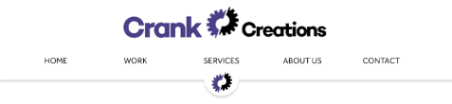

I wanted the navigation to be large when the user first landed on the page. This allowed the user to easily understand how to navigate through the website. It also helps the user to familiarise themselves with the company logo.

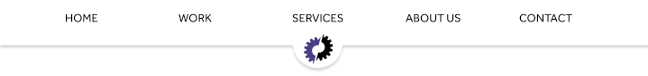

When the user scrolls through the page, the full logo is hidden. This is to prevent it dominating a large percentage of the screen when scrolling. The navigation is fixed to the top of the screen, but only with the short hand logo displaying below. The hide effect is done with JavaScript. It notices when the user has scrolled to a certain point on the screen and hides the full logo. When the user scrolls to the top of the page the full logo reappears.

#### Footer

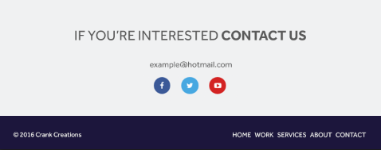

The footer is located at the bottom of each page. It is the same on every page. The footer is used to display information such as: licencing, extra navigation, social media links, contact details and a call to action. I added a small navigation at the bottom to allow users to access it faster, after they have read the content of a page. The ‘Contact Us’ text is hyperlinked to the contact page, to entice the user to take the first steps in communication; this is the call to action. I have chosen to use a minimalistic footer to allow the user to focus on the text I intend them to read. By keeping the text minimal, it reduces the chance the user will navigate away before reading.

### 1.2.2 Homepage Full page

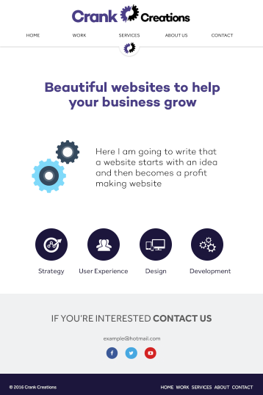

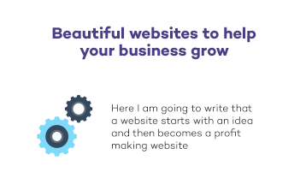

When the user first lands on the home page they initially see the title “Beautiful websites to help your business grow”. This instantly shows them the type of company page it is. Below the title is an icon accompanied a small amount of information.



Above the footer is a row of icons and headings, showing the user the most important services we provide. These icons and headers are hyperlinked to take the user to the services page. When displayed on a mobile device the icons sit in a single file to make it easier to view on a small width screen.

### 1.2.3 Work page Full page

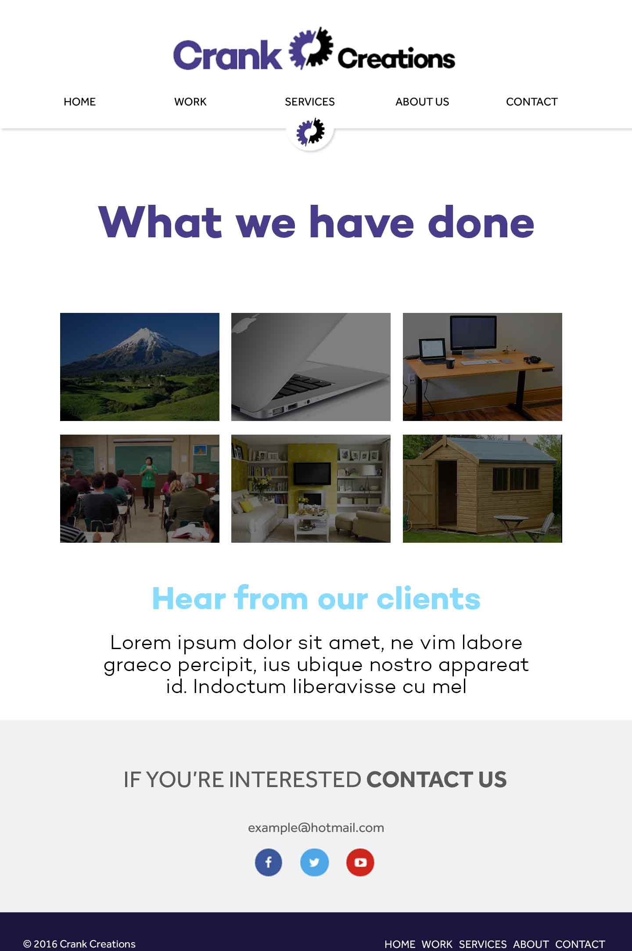

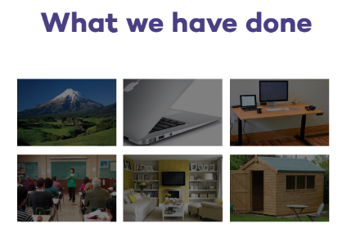

Just below the title I have organised a small thumbnail image gallery that allows the user to see an example image from the project created. These will have a hover function that will display the company name and project title. Once clicked it will take you to a stand-alone page for that specific project.

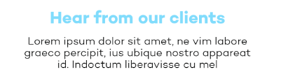

Below the project gallery there is a section showing testimonials acquired from clients previously worked with. Once I acquire more testimonials I will be able to display multiple in this section with a scrolling functionality using JavaScript.  
  
1.2.4 Services page  
  
Full page

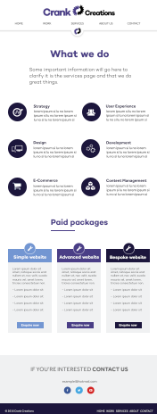

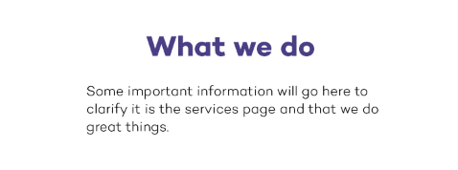When the user navigates to the services page the first bit of content they see will be a heading and sub-heading, explaining what page they are on. This will allow the user to instantly recognise the page they have navigated to.

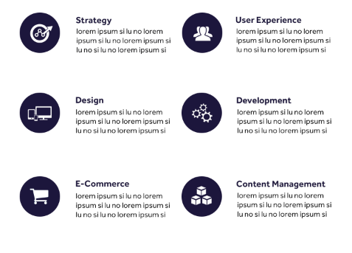

Below the title is the full list of services we provide. Each service has a correlating icon and a brief description about it. When the user views the website on a mobile device it arranges the icons in a single column for easy viewing.

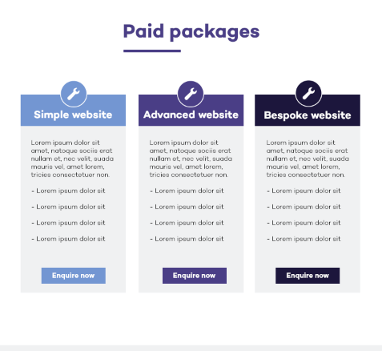

Below the list of services is a section displaying the website packages a user can choose. Those packages are: simple, advanced and bespoke (names may change). This gives the user a clear indication of the service they will receive, by seeing what package fits their desired website. Each package provides information to help the user select the correct one.

### 1.2.5 About page Full page

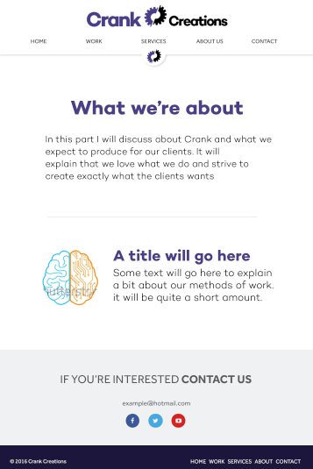

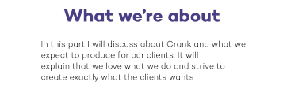

The title and sub-title show the user the page they have navigated to, and a small amount of information about it.

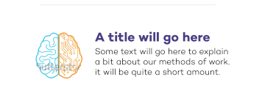

The section below the title explains the methods Crank Creations believe to be correct when designing and developing a website.  
  
1.2.6 Contact page  
  
Full page

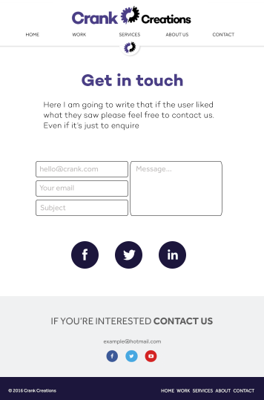

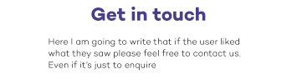

The title and sub-title shows the user the page they are on, and encourages them to contact us.

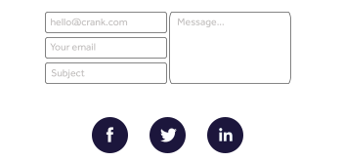

The contact page has an easy-to-use contact form. This allows the user to enter their information and message into an online form. This will get automatically sent to our company email. This process is to make it simple and easy to contact us. Below the contact form are icons linking to our social media websites.

## Appendix 1.3 – Illustration designs

#### Homepage

On the ‘homepage’ for the Crank Creations website I creating two illustrations. One is a gif animation with CSS3 animation around it, and the other is a static illustration.



The animated gif computer was created in Adobe Photoshop CC. It is a subtle animation of a computer switching on with the Crank Creations short hand logo as the computer brand.

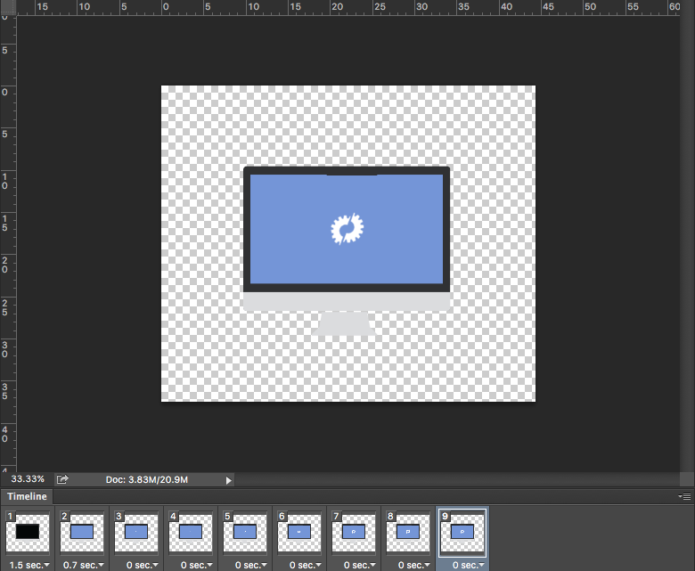

I edited my pre-existing icons and added them into the HTML document. I began positioning the icons with CSS. I then added a CSS animation effect onto the images when the page loaded to give them an attractive reveal.

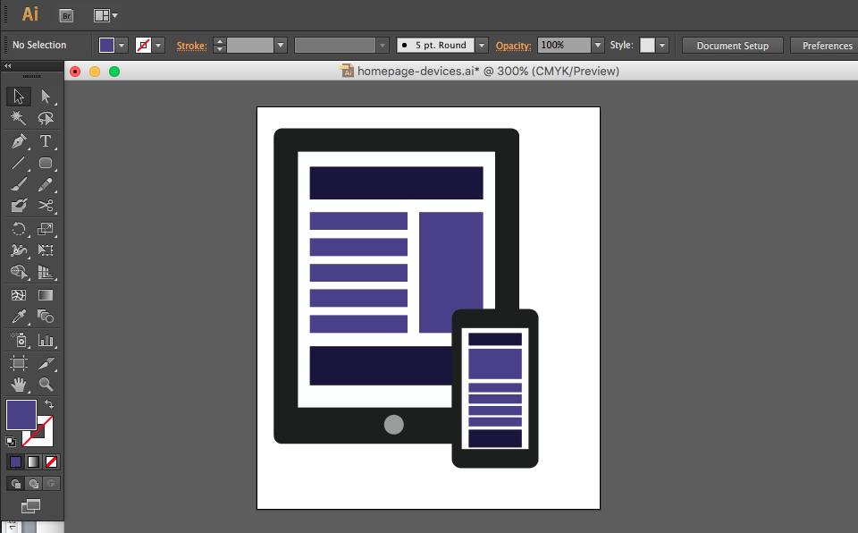

The illustration above was created in Adobe Illustrator CS6. It is a visual representation of a responsive layout that Crank Creations focus on creating with every project.  
  
Contact page

On the ‘contact page’ for Crank Creations, I produced a simple message sending gif animation, to make the page more exciting.



It is a modern illustration of a Pneumatic tube machine.[80] This is a machine used to send messages. The image was created in Adobe Illustrator CS6.[81]

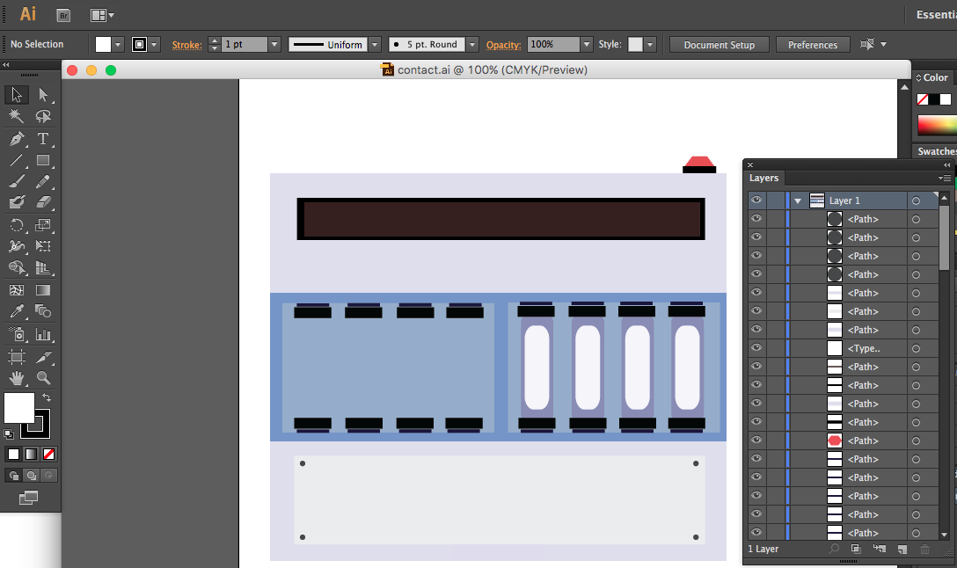 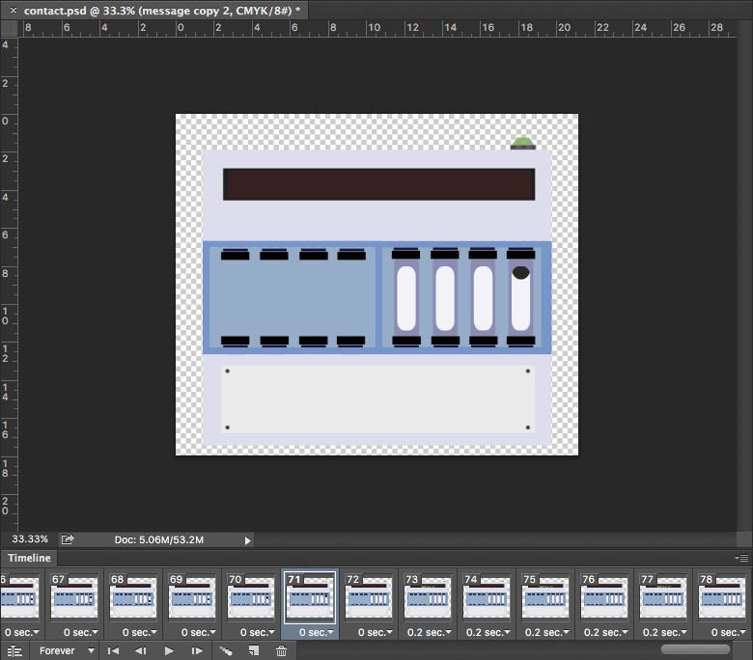

After the illustration was complete, I exported it into Adobe Photoshop CC.[82] I then began to create the Gif animation. The animation is 86kb in size and runs for approximately 7seconds. It is set to loop for continuous animation on the web page.  
  
About page

On the ‘about page’ I created two simple illustrations. One was a four-section cog that once clicked, displayed the four key points that make up a Crank Creator. The other was a simple heart with a cog in the middle. Both use the Crank Creations colour scheme.





The image was designed in Adobe Photoshop CC. It was then added into the HTML document and using JavaScript and CSS it was animated to hide and display once clicked.

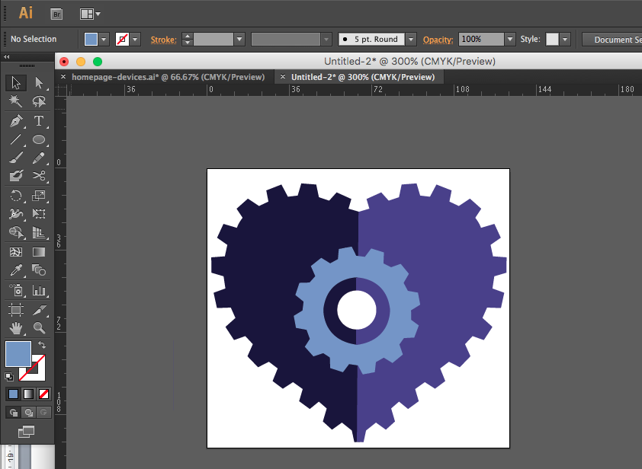

The image above was designed in Adobe Illustrator CS6 and added as a static image in the HTML.

# Appendix 2 – Usability test

#### Executive summary

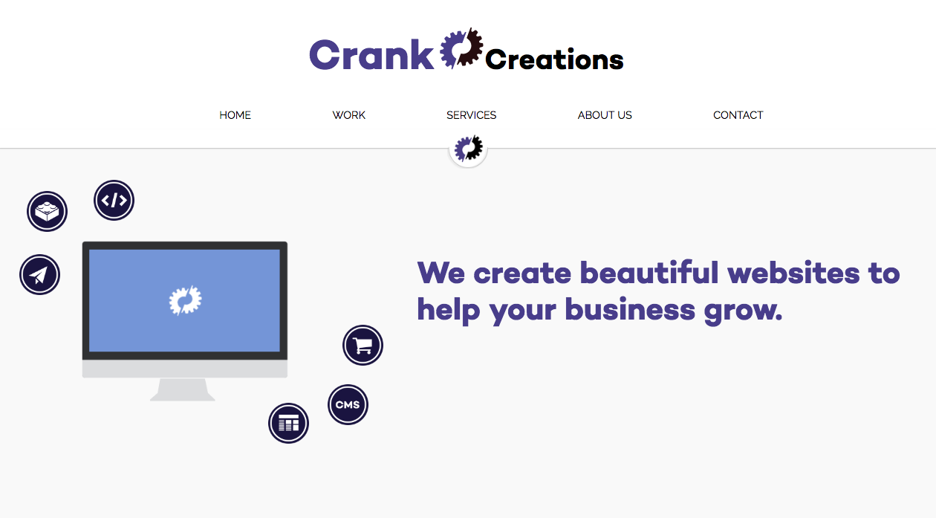

The product being testing in this report is [www.crankcreations.com](http://www.crankcreations.com). The test was conducted on the live website and the tested areas include: navigation, user experience, overall design and functionality.

The test was conducted on 4 individuals with varying ages and gender. Each participant completed a demographic questionnaire, consent & video releases form and a final feedback session to relay any information, positive or negative about the website.

#### Test objective

The overall aim of this usability test was to check the: design/functionality, user experience, content, errors and to gain opinions on the overall site. This was achieved by setting 5 activities for each participant to complete, based on common tasks expected to be done on a daily basis. Each task could be completed on desktop or mobile device; it was the choice of the participant per task to choose one. By analysing the: time taken, errors made and overall satisfaction, I was able to gain a better insight into how I could improve my company website. Each test is followed by a post-test feedback session where participants were asked if there was anything about the site they would like to mention, either positive or negative.   
  
Tasks

I have tested each task prior to the test to create time limits in which the tasks can be rated: fast, average or slow. Each task has a specific time limit bracket stated below. If the participant fits in the time limit bracket it would be considered an average speed. Below would be fast and above would be slow.

1. Find the packages used to help a client decide the type of website they want. **15-20 seconds**
2. Find Crank Creations philosophy. **20-25 seconds**
3. Find ‘Jem in the roughs’ individual client page. **25-32 seconds**
4. Find the form to email Crank Creations. **13-20 seconds**
5. Find and navigate to Crank Creations Facebook page. **15-20 seconds**

#### Table of participants

|  |  |  |  |  |  |
| --- | --- | --- | --- | --- | --- |
| Name | Age | Gender | How often do you use a computer? | Are you familiar with web design/ development? | If yes, what level would you class yourself? |
| Helena Mahoney | 25-40 | Female | Very often | No | N/A |
| Dominic Rathbone | 18-24 | Male | Very often | Yes | Intermediate |
| Daniela Campitelli | 18-24 | Female | Very often | Yes | Beginner |
| Matthew Lindsay | 18-24 | Male | Very often | Yes | Intermediate |

#### Participant’s computing environment

|  |  |
| --- | --- |
| **Hardware** | |
| **Computer** | MacBook Pro 13-inch, Early 2011 |
| **Software** | |
| **Operating system:** | Mac OS El Capitan 10.11.3 (15D21) |
| **Browser:** | Google Chrome Version 47.0.2526.106 (64-bit) |
| **Internet connection:** | BTHub5-6MR5 |

#### Test administrator environment

|  |  |
| --- | --- |
| **Hardware** | |
| **Computer** | MacBook Pro 13-inch, Early 2011 |
| **Mobile device** | Samsung Galaxy Ace 4 |
| **Software** | |
| **Computer operating system:** | Mac OS El Capitan 10.11.3 (15D21) |
| **Computer browser:** | Google Chrome Version 47.0.2526.106 (64-bit) |
| **Mobile operating system** | Android version 4.4.4 |
| **Mobile browser** | Google Chrome Version 4.0.3 |
| **Internet connection:** | BTHub5-6MR5 |
| **Screen Recording Program:** | QuickTime Player Version 10.1 (501.29). |
| **Face Recorder (Webcam):** | Photo Booth Version 4.0.2 (288.5) |

#### Consent & video release form

I agree to participate in the test conducted by Jamie Millman.

I understand that the participation in this test is entirely voluntary and if at any point I feel uncomfortable or unhappy with the proceeding of the test, I will make it clear to the facilitator.

I agree to be both video and audio recorded during my session.

Please sign and date below to indicate you have read and understood the information on this form and that any questions you may have had has been answered to your satisfaction.

**Signature:**

**Date:**

#### Demographic questionnaire

The demographic questionnaire was used to gain a better understanding of each participant and their computing knowledge. Allowing the feedback to be varied, ranging from technical issues to usability errors.

Macintosh HD:Users:jamiemillman:Documents:University Stuff:Year 3:Individual-Project:Customer Feedback - Google Forms.pdf

#### Results

The results gained from the usability test were insightful and beneficial. They helped me find design inconsistencies, and overall benefits to improve my company website. Each participant was asked to speak his or her mind to gain the thought process of each task. This was to help analyse potential errors or time constraints that may have arisen.

**Analysis by task**

**Task 1**

***“****Find the packages used to help a client decide the type of website they want.”*

None of the participants made any errors in navigating to the correct page for this task. The time taken by each participant was fast and concise. Each person achieved the task under the previously tested limit of 15-20 seconds.

Two participants separately tried to click on the short hand cog when trying to navigate back home. They expected it to either take them to the top of the page or home. This is something I had not implemented.

**Matthew Lindsay**

**Timestamp:** 0:50 face record 1:07 screen record

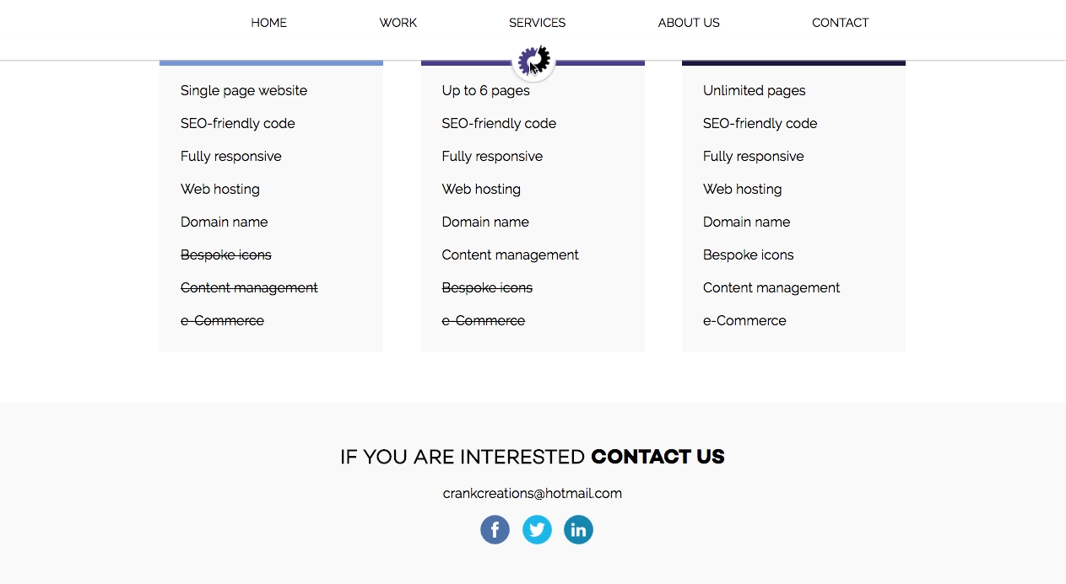

**Daniela Campitelli**

**Timestamp:** 0:57 face record 0:53 screen record

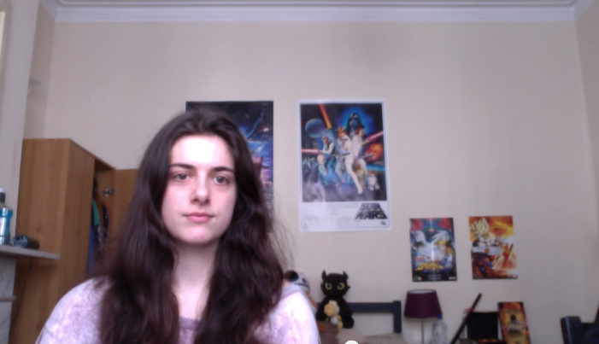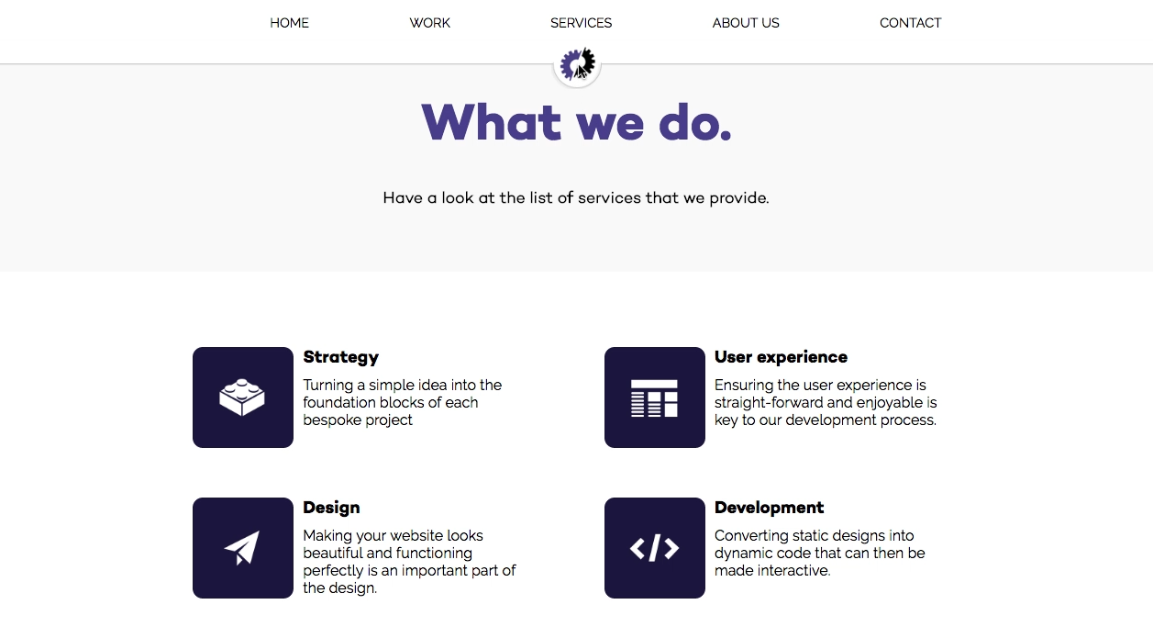

**Task 2**

*“Find Crank Creations philosophy.”*

There were no errors during this task. 3 participants completed the task in less than 20-25 seconds and 1 participant completed in 22 seconds. Making most participants a fast completion and one being average.

One participant mentioned there wasn’t mouse hover recognition when over the cog image. This was not automatically enabled and must be done in CSS.

**Matthew Lindsay**

**Timestamp:** 01:09 face record 01:43 screen record

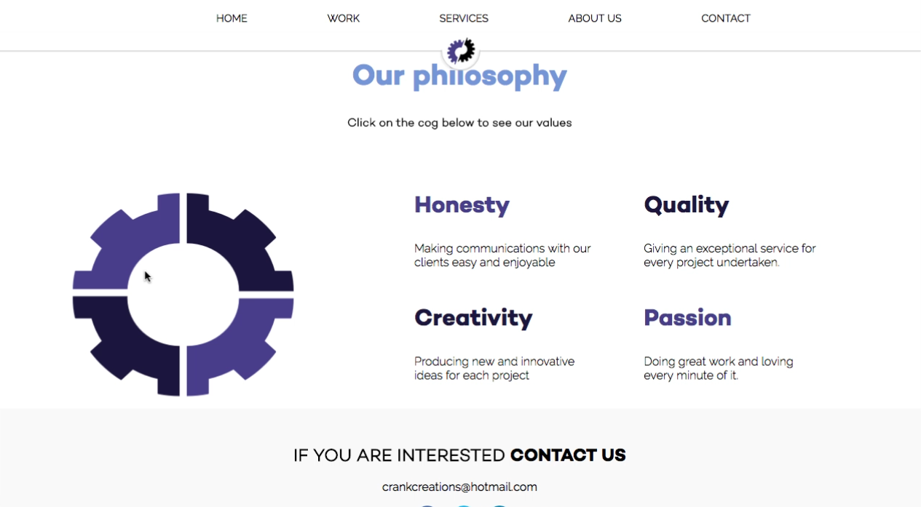

**Task 3**

*“Find ‘Jem in the roughs’ individual client page.”*

There were no errors in navigating to the selected page. Every participant successfully completed the task under 25-30 seconds.

One participant mentioned the examples of work were not clearly labelled enough. This would cause confusion when a user is looking for a specific piece of work.

Another participant mentioned there was not enough white space for the testimonial section. This could be problematic for users with impaired vision.

**Dominic Rathbone**

**Timestamp:** 02:22 face record 01:58 screen record

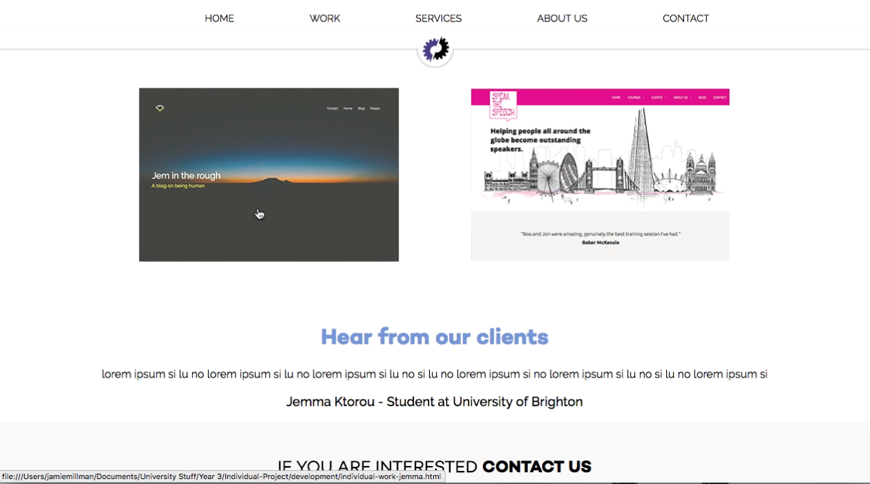

**Matthew Lindsay**

**Timestamp:** 01:31 face record

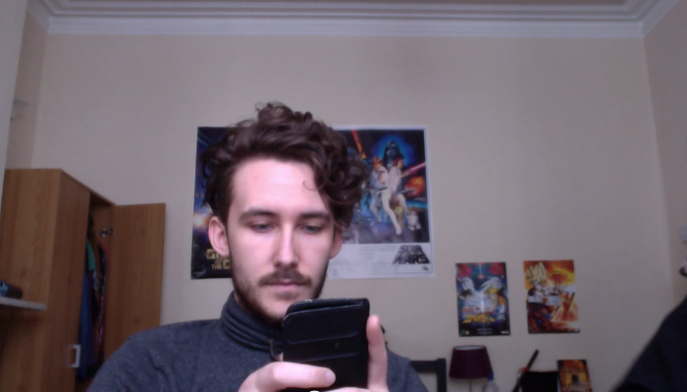

**Task 4**

***“****Find the form to email Crank Creations.”*

No errors were made during the navigation of this task. Every participant completed this task the fastest, and under 13-20 seconds.

One participant mentioned the contact form should be higher on the page. Allowing the user to instantly see it when navigating to the page. Either reversing the form and image or aligning them side-by-side could achieve this.

**Helena Mahoney**

**Timestamp:** 02:13 face record

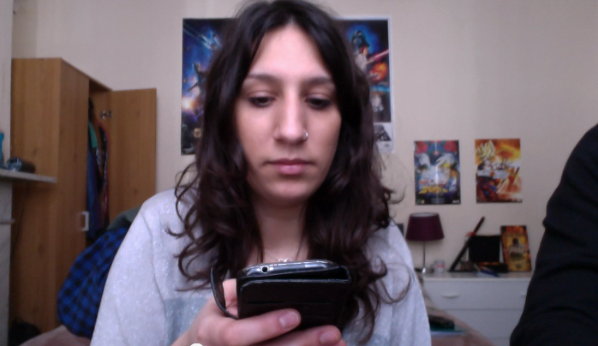

**Task 5**

*“Find and navigate to Crank Creations Facebook page.”*

Two participants navigated to the contact page to find Crank Creations Facebook link. I would not consider this an error as the Facebook link is in the footer of that page. Every participant completed the task in less than 15-20 seconds.

One participant mentioned not having larger social media icons within the contact page. However she was unsure whether this was bad or just different to what she was used to. Therefore I will consider adding larger buttons once the site grows in size.

**Daniela Campitelli**

**Timestamp:** 03:12 face record

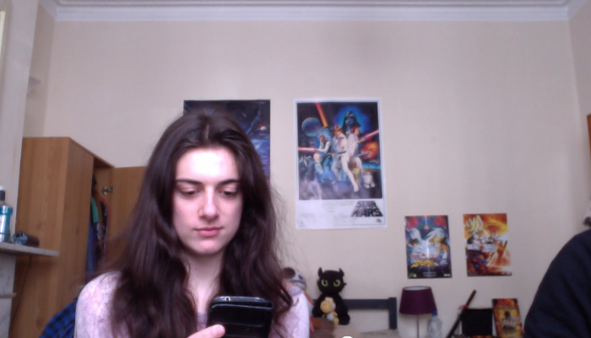

#### Post-test feedback

The feedback my website received after the tests were very beneficial. Most of the negative feedback and recommendations were stated during the tasks, however some valuable points were given after the test. Those were: indicating what page the user is on through the navigation, underline the ‘contact us’ in the footer to help show it’s a link, consider renaming “work” in the navigation text to be clearer and finally the service icons at the bottom of the homepage should take you to the services page and drop your view to that section.

The positive remarks said during the post-test feedback included: great colour scheme, good logo, clean design, good amount of whitespace, great icons throughout, clean fonts and easy to navigate.

#### Conclusion

The reception received from the usability test was positive. Points were made throughout the process that I had either forgotten to implement or hadn’t thought to. These critiques helped me outline sections of my website that needed to be improved. This further enhanced my website’s functionality and usability. The positive feedback reassured me that the planned decisions made in the research stages were the correct ones. This resonated through the participant’s structured analysis.

# Appendix 3 – Terms & Conditions

Below is a text-only version of Crank Creations Terms & Conditions. The standard version is a .pdf file that gets sent to the clients email address.  
  
Introduction

The following Terms & Conditions of Service apply to all products and services provided by Crank Creations. All work is carried out by Crank Creations once the client has stated they understand and agree to the Terms & Conditions.  
  
Project approval

During the proposal stage Crank Creations will provide the client with their Project Proposal and Terms & Conditions. It is the client’s responsibility to have read and understood both documents. Crank Creations will only commence a project once these documents are understood and accepted by the client.   
  
Payment terms

For payment terms please see your individual project proposal. All payments are to be made by bank transfer to details on the Invoice provided. At the time of the clients acceptance of the Project Proposal and Terms & conditions, a non-refundable deposit of fifty (50) per cent of the quoted fee (unless agreed otherwise) will become immediately due. Crank Creations will not begin to work on the project until this payment has been received. If the client requests additions/alterations at a later date, the fees are subject to change. The non-refundable deposit the client pays Crank Creations will be the acceptance of the Project Proposal and Terms & Conditions. The client is from then on legally bound to those documents.  
  
Source files

Crank Creations are the authors and owners of the intellectual property for the design and development files, these include: psd, ai, indd, fla, html, css, JavaScript or any other source files. If a client requires these files, they will be subject to a separate quotation or ‘buy-out’ charge.

#### Copyright

Crank Creations will not use any material provided by the client that they have not obtained the proper copyright permissions to use. The client must declare they have the permission and rights to use any of the information or files that are copyrighted by a third party.

When signing the project proposal it is the clients responsibility to have guaranteed to Crank Creations that all such permission have been obtained prior to the project commencing. The Client agrees to fully indemnify and hold Crank Creations free from harm in any and all claims resulting from the client in not having obtained all the required copyright, and/or any other necessary permission. Crank Creations may request evidence of permissions and authorities.

Any artwork, images, code or text supplied and/or designed by Crank Creations on behalf of the client, will remain the property of Crank Creations and/or it’s supplier.  
  
Credit

The client must agree to allow Crank Creations to use their websites and all designs, along with a link to the client’s site on Crank Creations portfolio page and all social media platforms.   
  
Alterations

Crank Creations cannot be held responsible for any alterations made by a third party before or after the clients project has been complete. Alterations include, but are not limited to, any changes, additions or deletions of the clients project.  
  
Liability

The client is expected to send duplicated content to ensure originals are not lost or damaged. If originals or duplicates are sent, Crank Creations are not liable for the loss or damage of this content.  
  
Licencing

Any design, text, illustration, idea or code created by Crank Creations for the client, or any other third party, is licenced for a single use only basis. It may not be modified, re-used or re-distributed in any way or form, without the full written consent of Crank Creations.   
  
Feedback

We will always take into consideration any feedback that a client has about the project. However we must also balance accordingly the project requirement and the target audience intended for each project. If we do not act upon your feedback do not take offence, as we want to produce the best possible project to meet your requirements and goals.

#### Rights of refusal

Crank Creations will not include any text, images or other data that is deemed to be immoral, offensive, obscene or illegal. All advertising material must abide to all of the standards advised by all relevant advertising standards authorities. In the situation where any images and/or data that Crank Creations include, and subsequently discovers is in violation to such Terms & Conditions, the Client is obligated to allow Crank Creations to remove the violation without hindrance, or penalty. Crank Creations is to be held in no way responsible for any such data being included.  
  
Termination

Termination of services by the client may be initially made by telephone or e-mail, however Crank Creations will need a formal notification in writing to be sent to Crank Creations postal or e-mail address. The client will be invoiced for all work completed to the date of the first termination notice and payment must be made in full within thirty (30) days.   
  
SEO

Crank Creations do not focus on the ranking of a clients website. We produce SEO friendly code but are not responsible for managing the overall ranking of the clients website.  
  
Domain and hosting

Crank Creations may purchase domain names and hosting plans on behalf of the client. However the payment and renewal is the responsibility of the client. Crank Creations are not responsible for any loss, cancellation or any other negative effect that occurs due to late or no payment.   
  
Default

Invoices unpaid up to thirty (30) days from once received will turn the clients account default. For every day the client’s account is default an additional charge of 10% will be added to the final amount owed (unless agreed otherwise). Clients with their accounts in default agree to pay for all expenses, including legal fees and costs for collection by third party agencies, acquired by Crank Creations to enforce these Terms & Conditions.  
  
Law

This agreement shall be upheld and governed by English law.  
  
Indemnity

Crank Creations will not allow their services to be used for any unlawful purposes. The client must agree that they will not hold Crank Creations responsible for any misuse of our services that damages you or any third party.

**STAGES STILL TO DO**

* **MAKE WEBSITE WC3 VALIDATED**

1. Brighton fuse. (2011). *Brighton fuse.* Available: http://www.brightonfuse.com/. Last accessed 12th Nov 2015.
2. Wired sussex. (2015). *BUILDING BETTER DIGITAL BUSINESS TOGETHER.* Available: http://www.wiredsussex.com/. Last accessed 16th Nov 2015.
3. University of Brighton. (2015). *University of Brighton.* Available: https://www.brighton.ac.uk/index.aspx. Last accessed 16th Nov 2015.
4. University of Sussex. (2015). *University of Sussex.* Available: http://www.sussex.ac.uk/. Last accessed 16th Nov 2015.
5. National Centre for Universities and Business. (2016). *National Centre for Universities and Business.* Available: http://www.ncub.co.uk/. Last accessed 16th Nov 2015.
6. Sapsed, J & Nightingale, P. (2013). *The Brighton Fuse.* Available: http://www.brightonfuse.com/wp-content/uploads/2013/10/The-Brighton-Fuse-Final-Report.pdf. Last accessed 10th Nov 2015.
7. Wired Sussex. 2013. *Findings from The Brighton Fuse Report.* [online]. [10th Nov 2015]. Available at: https://www.youtube.com/watch?v=GgFl_R_sANw
8. University of Sussex. (2015). *Brighton Fuse 2 Project: The Role of Freelancers in the Brighton’s Creative Digital IT Cluster.* Available: http://www.sussex.ac.uk/spru/research/tim/timresearch/brightonfuse2. Last accessed 10th Nov 2015.
9. Sapsed, J. (2015). *Brighton Fuse 2: Freelancers in the Creative Digital IT Economy.* Available: http://www.brightonfuse.com/wp-content/uploads/2015/01/brighton_fuse2_online.pdf. Last accessed 10th Nov 2015.
10. LaunchSpark Video. 2013. *What is The Lean Startup?.* [Online]. [11th November 2015]. Available from: https://www.youtube.com/watch?v=_a3s0IXSuxY.
11. Eric Ries (2011). *The Lean Startup*. USA: Crown Business (USA). p1-336.
12. Built by buffalo. (2006). *Built by buffalo.* Available: http://builtbybuffalo.com/. Last accessed 2nd Dec 2015.
13. Foundation. (1998). *Foundation.* Available: http://foundation.zurb.com/. Last accessed 2nd Dec 2015.
14. Clearleft. (2015). *We design compelling digital experiences..* Available: http://clearleft.com/. Last accessed 22nd Jan 2016.
15. Aizlewood, J. (2013). *On pattern portfolios.* Available: http://clearleft.com/thinks/118. Last accessed 8th Dec 2015.
16. Ten 4. (2015). *WHAT WE DO.* Available: http://www.ten4design.co.uk/info. Last accessed 16th Dec 2015.
17. Ten4. (2015). *Ten4 Framework.* Available: https://github.com/ten4design/ten4-framework. Last accessed 2nd Dec 2015.
18. Craft cms. (2015). *Focused Content Management.* Available: https://craftcms.com/. Last accessed 2nd Dec 2015.
19. Slim. (2015). *Slim.* Available: http://www.slimframework.com/. Last accessed 8th Dec 2015.
20. Bootstrap. (2015). *Bootstrap 4 alpha.* Available: http://blog.getbootstrap.com/2015/08/19/bootstrap-4-alpha/. Last accessed 10th Dec 2015.
21. Sublime Text. (2015). *Sublime Text.* Available: http://www.sublimetext.com/. Last accessed 10th Dec 2015.
22. Brackets. (2015). *A modern, open source text editor that understands web design..* Available: http://brackets.io/. Last accessed 10th Dec 2015.
23. Git. (2015). *Fast version control.* Available: https://git-scm.com/. Last accessed 10th Dec 2015.
24. Sass. (2006). *CSS with superpowers.* Available: http://sass-lang.com/. Last accessed 4th Dec 2015.
25. Less. (2015). *Getting started.* Available: http://lesscss.org/. Last accessed 10th Dec 2015.
26. Chris Coyier. (2012). *Poll Results: Popularity of CSS Preprocessors.*Available: https://css-tricks.com/poll-results-popularity-of-css-preprocessors/. Last accessed 4th Dec 2015.
27. Skeleton. (2015). *A dead simple, responsive boilerplate..* Available: http://getskeleton.com/. Last accessed 10th Dec 2015.
28. Gulp. (015). *Automate and enhance your workflow.* Available: http://gulpjs.com/. Last accessed 15th Dec 2015.
29. Twitter. (2015). *960 grid system.* Available: http://960.gs/. Last accessed 15th Dec 2015.
30. Fluidable. (2015). *Fluidable.* Available: http://fluidable.com/. Last accessed 17th Dec 2015.
31. Onepcssgrid. (2012). *One% CSS Grid.* Available: http://onepcssgrid.mattimling.com/. Last accessed 17th Dec 2015.
32. Drewniak, J. (2015). *Creating Your Own CSS Grid System.* Available: http://j4n.co/blog/Creating-your-own-css-grid-system. Last accessed 10th Feb 2016.
33. Coffee script. (2009). *CoffeeScript is a little language that compiles into JavaScript.* Available: http://coffeescript.org/. Last accessed 10th Dec 2015.
34. Jeffrey Way. (2011). *Should You Learn CoffeeScript?.* Available: http://code.tutsplus.com/articles/should-you-learn-coffeescript--net-23206. Last accessed 7th December 2015.
35. Normalize.css. (2015). *A modern, HTML5-ready alternative to CSS resets.* Available: https://necolas.github.io/normalize.css/. Last accessed 10th Dex 2015.
36. Meyer, E. (2015). *2016’s most popular CSS Reset scripts, all in one place.* Available: http://cssreset.com/. Last accessed 11th Dec 2015.
37. Gallagher, N. (2016). *normalize.css.* Available: http://necolas.github.io/normalize.css/. Last accessed 11th Feb 2016.
38. Gallagher, N. (2012). *About normalize.css.* Available: http://nicolasgallagher.com/about-normalize-css/. Last accessed 11th Feb 2016.
39. Modernizr. (2015). *Respond to your user’s browser features..*Available: https://modernizr.com/. Last accessed 10th Dec 2015.
40. Featurejs. (2016). *Feature.js, a feature detection library in 1kb.*Available: http://featurejs.com/. Last accessed 11th Feb 2016.
41. Erik Krieg. (2015). *pure JavaScript vs. jQuery.* Available: https://teamtreehouse.com/community/pure-javascript-vs-jquery-2. Last accessed 20th Dec 2015.
42. Pattern lab. (2015). *Pattern lab.* Available: http://patternlab.io/. Last accessed 17th Dec 2015.
43. Pew research center. (2014). *Social Networking Fact Sheet.* Available: http://www.pewinternet.org/fact-sheets/social-networking-fact-sheet/. Last accessed 10th April 2016.
44. Top 15 Most Popular Social Networking Sites. (2015). *Top 15 Most Popular Social Networking.* Available: <http://www.ebizmba.com/articles/social-networking-websites>. Last accessed 11th Dec 2015
45. Nutella. (2013). *Nutella.* Available: https://www.facebook.com/nutellauk/?brand_redir=24932281961. Last accessed 11th Dec 2015.
46. Top 15 Most Popular Social Networking Sites. (2015). *Top 15 Most Popular Social Networking.* Available: <http://www.ebizmba.com/articles/social-networking-websites>. Last accessed 11th Dec 2015
47. Eric Sornoso. (2014). *9 Small Business Twitter Marketing Examples to Study.* Available: http://www.socialmediaexaminer.com/small-businesses-twitter-marketing/. Last accessed 14th Dec 2015.
48. Top 15 Most Popular Social Networking Sites. (2015). *Top 15 Most Popular Social Networking.* Available: <http://www.ebizmba.com/articles/social-networking-websites>. Last accessed 14th Dec 2015
49. Bee Purple. (2015). *beepurple - Enterprise Skills.* Available: http://about.brighton.ac.uk/careers/enterprise. Last accessed 18th Dec 2015.
50. Gov.uk. (2015). *Sole trader.* Available: https://www.gov.uk/business-legal-structures/sole-trader. Last accessed 8th March 2016.
51. Gov.uk. (2015). *Limited company.* Available: https://www.gov.uk/business-legal-structures/limited-company. Last accessed 8th March 2016.
52. Wired Sussex. (2016). *Get wired today.* Available: http://www.wiredsussex.com/members/. Last accessed 8th March 2016.
53. Simpson, M. (2013). *What is Professional Indemnity Insurance.*Available: https://www.know-insurance.co.uk/business/what-professional-indemnity-insurance. Last accessed 26th Jan 2016.
54. Investopedia. (2016). *Property Insurance.* Available: http://www.investopedia.com/terms/p/property-insurance.asp. Last accessed 26th Jan 2016.
55. Wipo. (2016). *What is Intellectual Property?.* Available: http://www.wipo.int/about-ip/en/. Last accessed 26th Jan 2016.
56. Chmielewski, T. (2016). *What Happens If Someone Breaks a Copyright Law?.* Available: http://smallbusiness.chron.com/happens-someone-breaks-copyright-law-55834.html. Last accessed 26th Jan 2016.
57. Legislation.gov.uk. (). *Copyright, Designs and Patents Act 1988.*Available: http://www.legislation.gov.uk/ukpga/1988/48/contents. Last accessed 26th Jan 2016.
58. W3C. (2012). *Web Content Accessibility Guidelines (WCAG) Overview.*Available: https://www.w3.org/WAI/intro/wcag.php. Last accessed 29th Jan 2015.
59. Wikipedia. (2016). *User agent.* Available: https://en.wikipedia.org/wiki/User_agent. Last accessed 30th November 2015.
60. Strategyzer. (2015). *The Business Model Canvas.* Available: http://www.businessmodelgeneration.com/canvas/bmc. Last accessed 23rd November 2015.
61. Berry, T. (2009). *What is a Business Plan?.* Available: http://articles.bplans.co.uk/writing-a-business-plan/what-is-a-business-plan/384. Last accessed 8th March 2016.
62. Griffiths, C & Crescenzo, B (2013). *My Start-up Plan*. 2nd ed. Hampshire: Harriman house LTD. p1-25.
63. Built by buffalo. (2006). *Built by buffalo.* Available: http://builtbybuffalo.com/. Last accessed 2nd Dec 2015.
64. Code 7. (2007). *A creative digital agency.* Available: http://www.code7.co.uk/. Last accessed 2nd Dec 2015.
65. Bushell, C et al.. (2014-2015). *Code 7 Reviews.* Available: https://www.google.co.uk/search?q=code+7+reviews&ie=utf-8&oe=utf-8&gws_rd=cr&ei=FaJAVu1Hga5SjIyVsAY#gws_rd=cr&lrd=0x4875855ba68e09a9:0xece3bbded965e414,1. Last accessed 9th Nov 2015.
66. Code 7. (2007). *Projects.* Available: http://www.code7.co.uk/projects/. Last accessed 2nd Dec 2015.
67. Design super. (2015). *Beautiful, easy to use websites and applications to help your business grow.* Available: http://designsuper.co/. Last accessed 2nd Dec 2015.
68. Roweena. (2015). *Roweena.* Available: http://www.roweena.co.uk/. Last accessed 2nd Dec 2015.
69. Chapman, A. (1999-2015). *pest market analysis tool.* Available: http://www.businessballs.com/pestanalysisfreetemplate.htm. Last accessed 10th Nov 2015.
70. Baseel, C. (2014). *Eight Japanese words we’d love to import into English.* Available: http://en.rocketnews24.com/2014/04/08/eight-japanese-words-wed-love-to-import-into-english/. Last accessed 4th Feb 2016.
71. Matt Siltala. (2013). *Color Emotion Guide.* Available: http://visual.ly/color-emotion-guide. Last accessed 29th Nov 2015.
72. Eden, D. (2015). *Animate.css.* Available: https://daneden.github.io/animate.css/. Last accessed 31st March 2016.
73. Font fabric. (2014). *Campton free font.* Available: http://www.fontfabric.com/campton-free-font/. Last accessed 7th January 2016.
74. Font squirrel. (2015). *Webfont generator.* Available: http://www.fontsquirrel.com/tools/webfont-generator. Last accessed 7th January 2016.
75. Google. (2016). *Google Fonts.* Available: https://www.google.com/fonts. Last accessed 7th April 2016.
76. Browserling. (2016). *Live interactive cross-browser testing.* Available: https://www.browserling.com/. Last accessed 28th April 2016.
77. Speak the speech. (2016). *London based company offering training and courses throughout Europe.* Available: http://speakthespeech.co.uk/. Last accessed 29th April 2016.
78. Bee Purple. (2016). *Directory of Beepurplers’ Businesses.* Available: http://about.brighton.ac.uk/careers/enterprise/beepurplers-businesses-directory/. Last accessed 18th April 2016.
79. The Farm. (2016). *Brighton's Best New Media Freelancers.* Available: http://www.brightonfarm.com/. Last accessed 26th April 2016.
80. Aerocom. (2016). *Your partner for pneumatic tube systems.* Available: http://www.aerocom.co.uk/air-tube-systems/. Last accessed 28th April 2016.
81. Adobe. (2016). *Create beautiful vector art..* Available: http://www.adobe.com/uk/products/illustrator.html. Last accessed 8th April 2016.
82. Adobe. (2016). *Create anything you can imagine. Anywhere you are..*Available: http://www.adobe.com/uk/products/photoshop.html. Last accessed 8th April 2016.